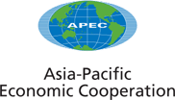
________________________________________________________________
2001/AMM/035

Energy Security Initiative

Submitted by: EWG

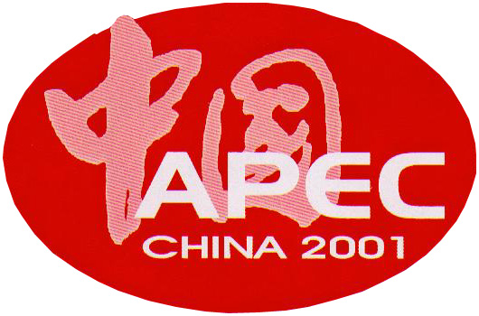 | 13th APEC Ministerial Meeting  Shanghai, China  17-18 October 2001

ENERGY SECURITY INITIATIVE

Background

APEC Economic Leaders, at their meeting in Brunei-Darusalam in November 2000, acknowledged the risks to the global economy posed by volatility in the international oil market and have called for appropriate measures to promote stability.

The APEC Energy Working Group is mandated to address energy issues by:
- strengthening the security and reliability of affordable energy to all within our APEC community;
- facilitating energy efficiency and conservation;
- facilitating improved reliability and stability in the provision of energy supply to meet demand;
- facilitating energy technology development, exchange, application and deployment; and
- facilitating a diverse and efficient supply mix
as reflected in the Energy Working Group Future Directions Strategic Plan.

The Initiative

Given the importance of energy security to the region’s economic, social and environmental goals, a series of workshops (Tokyo, Houston, Seoul, Bangkok and Port Moresby) identified the need to develop a strategic approach. This strategic approach comprises measures to respond to temporary supply disruptions and longer-term policy responses to address the broader challenges facing the region’s energy supply, that are practical in a policy context and acceptable in a political context.

To achieve this, APEC's fundamental principles of cooperation, voluntary participation and mutual respect must be recognised and the widely differing circumstances between economies should be respected. Reflecting the significant diversity of energy resource endowment, economic development, and environment of the member economies, measures that may be effective for some, will not apply or be acceptable to others. It is thus important for economies to have a range of options that can be drawn on by economies that so wish.

Both short- and longer-term options should form part of a strategic approach to energy security in the APEC region.

Concerning short-term preparedness options, a number of economies put high priority on emergency oil stocks, while others prefer demand restraint and/or surge production of oil. Among the medium-to-long term options for energy security are reform of energy markets, energy conservation, diversification of energy supplies through development of clean fossil energy, renewable energy, other alternative energy sources and improving energy efficiencies.

The strategic approach will comprise a series of specific collaborative projects under the same common theme. These projects will utilise the resources and expertise of the Expert Groups and will be managed by EWG members.

A key element of this initiative should be to highlight and strengthen the linkages of work that the EWG is already undertaking through special projects or through the Expert Group programs.

The following are a range of possible collaborative projects, building on the outcomes of the Bangkok Workshop in particular.

Short Term Policy Approaches

- strengthening of systems for collecting and analysing oil data to enhance oil market transparency and stability;
- development of mechanisms for international sharing of real time information during oil emergencies;
- examination of oil stock holding options, including possible (joint) stockpiling for oil importing member economies to provide a short term cushion;
- investigate options for short term surge production, for those with production capability, to the extent feasible;
- examine demand restraint measures including taking into account essential service provisions;
- examine the introduction of legislative and institutional arrangements needed to bring all or some of these measures into effect;
- investigate possible sea lane security issues at oil transport chokepoints.

Longer Term Policy Approaches

- explore alternative fuel sources and measures to conserve and use energy more efficiently and to safeguard the environment.
- identify impediments to trade and investment in energy exploration and development, especially oil;
- explore fiscal and regulatory regimes that encourage oil exploration and development;
- improve energy system resilience by investigation and implementation of measures such as supply and fuel diversification particularly for stationary energy purposes;
- identify the impediments to diversifying supply source for oil;
- encourage the installation of more energy efficient technologies and practices in production, transportation and consumption;
- establish co-operative action on R&D for alternative transport fuels, and

Underlying all of the above is the very important relationship between energy security and sustainable development.

Next Steps

The following concrete works are envisaged in the forthcoming months:

- APEC will evaluate the oil data initiative ongoing in cooperation with several international organisations (IEA, OPEC etc) after their meeting scheduled in Riyadh to review the six month trial data collection exercise;

- a workshop on sharing information on oil data initiative and oil stocks be proposed to be held prior to or in conjunction with EWG23;

- as a first step to materialise real-time international information sharing in an oil supply emergency situation, the EWG will work to establish a network among APEC members, who wish to participate; and

- to deal with the possibility of sea lane disruption, a workshop will be held in Tokyo in the second quarter of 2002, as part of APERC activities.

A greater involvement of the business community will be sought in the pursuit of the overall Energy Security Initiative.

Strengthening of relationships within the region and close dialogue among the oil producing and consuming economies and with other international organizations is critical for oil market stability. In this regard, APEC economies take note of Japan’s commitment to host the 8th Meeting of the International Energy Forum (September 21-23, 2002 in Osaka) - the producer-consumer dialogue - as an excellent contribution.

As part of a commitment to longer-term energy security, it is recommended that the EWG continue to encourage the exchange of experiences and information between member economies in approaches to energy security, through workshops, seminars, and the use of Implementation Facilitation Assistance Teams (IFAT), where appropriate. The EWG should also consider the development of a manual of best practice principles to address longer-term energy security, based on the experiences and approaches identified by member economies.

The EWG should also consider additional initiatives to enhance energy security that will be undertaken by the relevant Expert Groups. Such initiatives could include the analysis of the role of energy efficiency in addressing oil demand, increased productivity and competitiveness, environmental aspects related to greenhouse gas emissions, encouraging investment in alternative energy sources, and the development of clean energy technologies.

The EWG Secretariat will provide advice in the near future as to how the EWG will address the longer term policy approaches.

