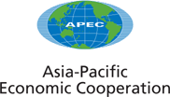
__________________________________________________________________________________________
2004/SOM1/CTI/042
Agenda Item: 5 (c)

Report of 11th Steering Committee of APEC Automotive Dialogue

Purpose: Information
Submitted by: Indonesia

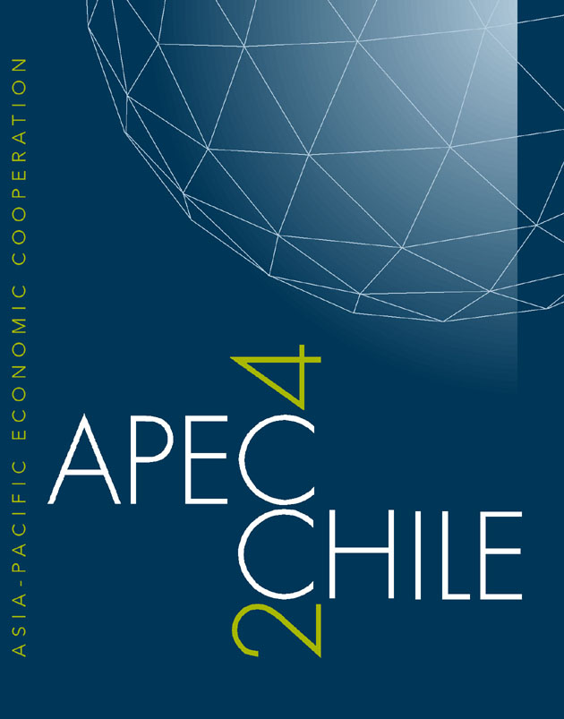 | First Committee on Trade and Investment Meeting  Santiago, Chile  29 February - 1 March 2004

Report of 11th Steering Committee of APEC Automotive Dialogue
Hanoi, Vietnam, 8th ~ 9th October 2003

The APEC Automotive Dialogue organized by the SCM has conducted the 11th regular meeting in Hanoi, Vietnam from 8th to 9th October 2003. Eighty five public and private sector representatives attended the SCM representing Australia, China, Indonesia, Japan, Korea, Malaysia, Philippines, Chinese Taipei, Thailand, USA, and Vietnam. India attended the SCM as an observer.

The meeting unanimously adopted the draft Agenda and continued on the Business Arrangement, and with regard to the annual contribution to the Dialogue. The Chair noted that economies, which have not fulfilled their contribution were encouraged to do so. It was agreed that administrative expenses incurred while hosting the 11th SCM would be forwarded to Vietnam in accordance with the previous practice.

Outstanding Automotive Dialogue Business
It was noted that SOM had endorsed the Automotive Dialogue recommendation for a standstill on measures affecting the automotive sector and had forwarded language to Ministers for inclusion in the APEC Ministerial Meeting Statement.
The U.S. submitted an amended draft of the package of trade facilitation and ecotech measures that would be completed for review at the 12th SCM after economies submit their comments. Prior to the completion of the draft, economies agreed to submit comments by 15th November 2004, and to have a final draft completed for review at 12th SCM.

Report on WTO Vertical (Sectoral) Automotive Initiative
the U.S. Government and U.S. Industry gave an update on development in the WTO concerning modalities for non–tariff barriers (NTBs) in the DDA non-agricultural market access negotiations. The proposed modalities could include request/offer, horizontal and vertical approaches.
The SCM was informed that interest government and automotive industry representatives had already begun meeting informally to discuss elements of a possible vertical agreement in the automotive sector. Members of the Automotive Dialogue were invited to consider participating in future meetings of the informal group in Geneva or otherwise to ensure that their Geneva representatives were informed about automotive issues of interest to individual economies. Delegations expressed appreciation for update these developments, especially relating to Cancun WTO Ministerial Meeting.

Working Groups Reports

Market Access Working Group

This working group presented an amended paper amalgamating earlier drafts of four separate paper addressing the impact of NTBs on the APEC automotive sector in the following areas:

Automotive Technical Regulation/Certification Requirements,

Customs Practices and Procedures,

Investment Requirements and Restrictions, and

Intellectual Property Rights

Participating economies should provide final inputs and comments by November 15th 2003. The working group will consider any further comments and inputs and circulate proposed final paper as soon as possible thereafter. It was noted that, if necessary, a disclaimer would be added to the paper indicating that any expressions of opinion in the paper were the sole responsibility of the Chair of the Market Access Working Group and could not necessarily be considered to be representative of the views on any participating economy. The finalized paper will serve as an information resource for participating APEC economies.
In preparation for the 6th Automotive Dialogue, the group would develop work program covering:
- Develop a paper examining the possible market access implications of different preferential rules of origin arrangement
- Develop a paper examining the meaning and implications of the automotive standstill provision.
- Initiate an interactive email distribution group for Automotive Dialogue participants providing a mechanism to access information and exchange views on the discussions underway on negotiating the WTO non-agriculture Market Access (NAMA) Working Group.
ATPC, JAMA and FCAI indicated that they would collaborate on the development of draft papers circulated to participating economies by early-March 2004.

- Harmonization Working Group
This is WG was briefed on the September 2003 Road Transport Harmonization Project (RTHP) Group focusing on the ASEAN Cooperative Arrangement for Automotive Technical Regulations (ACAATR) and core regulations. Japan and Australia submitted revisions on the draft paper of ACAATR, and the Steering Committee agreed to submit final paper to the Chair by 17th October, and will be forwarded to the Automotive Dialogue.
Under the topic of new business, the group raised the following points:
- the U.S. announced an economic and technical assistance program to support regional integration of ASEAN’s auto safety and environment standards
- ASEAN Automotive Federation (AAF) reiterated that ASEAN have interest in pursuing an MRA
- Thailand expressed its interest to continue working within the group, and would seek assistance on the actual implementation of an ASEAN MRA
- Malaysia thinks that ACAATR is a useful paper

- Customs Working Group
The Steering Committee discussed the Paper of Customs Best practices in response to the APEC Leaders’ instructions to develop action plan to cut transaction cost by five percent in the APEC region by 2006.
Recognizing that many economies are interested in establishing best practices, Chair of the group asked economies to indicate which specific customs process they would like to improve. In this regard, the group needs to seek capacity building/infrastructure funding grants to establish economy-specific projects.
With a number of FTA negotiations within APEC, rules of origin are being re-examined. The multitude of different rules creates uncertainty and cost for both the government and private sector. The steering Committee agreed this is an opportunity to review all these initiatives.
Customs working group proposed a discussion paper detailing major existing rules of origin regimes. Once the paper has been drafted, it will be circulated intersessionally for comments.
It was noted that counterfeiting is becoming one of the most serious economic crimes affecting auto industry’s profits, brand images and consumer safety. Therefore, the group considered establishing an IPR working group to deal with the issue.

- Environment Working Group
The working group took note presentation on the Future Automotive Technology & Motor Fuel for Advance Low-emission Vehicles, which outlined Japan’s new policies and advance technologies designed to reduce environment impact caused by the use of motor vehicles.
The U.S. presented a draft paper summarizing policies of APEC member economies concerning restrictions on imports of used vehicles. The working Group agreed that economies would submit their tariff policies relating to imports of used vehicles and parts to the U.S. coordinator prior to the end of the year.
The meeting also agreed to revisit the paper on used vehicles prepared by the Philippines.
- Information Technology Working Group
The group discussed topics such as ASEAN auto-parts Portal site, APEC supplier site project, Other Initial Projects, and Future Work Plan.
With regard to the ASEAN auto-parts Portal site, Thailand reported that economies intending to establish their National Supplier can benefit from the portal that has been set up in Thailand, and operated since July 2002. The site designed to store data of parts industry in Thailand as well as from other ASEAN countries. Necessary arrangement has already been made to expand this system to economies other than Thailand. Based on this progress, member economies are offered to utilize the “ASEAN Auto-Parts Portal site” when making their own database of parts companies.
The Chair reported that the APEC Supplier Site has been established on the APEC’s official website. It was also reported that four economies (Australia, Japan, Korea and Thailand) appear on the website. Other economies are encouraged to quickly catch up with efforts of those four initial economies in order to enhance transactions between auto manufactures and parts suppliers in APEC region. The site is: http://www.apecsec.org.sg/apec/business resources/industry dialogues/automotive dialogue/apec auto-parts supplier.html
With regard to collaboration with other APEC fora, member economies shared the views that the e-commerce SGG, SME WG, and Telecom WG as well as Ecotech WG may be regarded as suitable candidates to joint the work.
The group agreed on the future work plan covering a comprehensive and informative report on the optimal way applying IT in the Automobile Industry (by Japan), a proposal of joint work with other for a (by the Chair), and a proposal for the new action plan.

- Ecotech Working Group
the group initial work programs focus on assisting parts and components manufactures in the ASEAN region. Its present and planed programs include; i) Adopt QMS in ASEAN auto parts SMEs, ii) provide assistance to ASEAN conomies in their effort s to develop ACAATR), iii) collaborate with the IT WG in linking ASEAN parts suppliers, and iv) collaborate with other working groups to explore possible establishment ASEAN Center for Automotive Technology.

Vietnam Peer Review
Delegates noted how helpful and appropriate it was for a peer review to be conducted concerning the Vietnamese automotive market and policies. The AAF commented that they had faced the difficult adjustment process in the early stages of development of their automotive sectors and offered to share their experiences with Vietnam. Key challenges highlighted by the U.S. during the discussion included the importance of: 1) developing skills to encourage localization, 2) providing good transportation infrastructure, 3) focusing policy development in a consistent and practical direction, 4) targeting specific areas for local parts manufacturing and 5) moderating tariff and tax rates to drive consumer demand and grow the automotive sector. It was noted that this discussion and joint cooperative efforts to address issues important to the development of a healthy automotive sector was the basis of the founding concept of APEC Automotive Dialogue.
The Vietnam Automotive Manufacturers Association (VAMA) established in August 2000 to encourage the development of the Vietnam automotive industry and economic growth. VAMA currently represents eleven manufacturers from the U.S., Japanese, Korean, and European global brands. Today industry total investment is $526 million and production capacity is 148,000 units/year, but only 20 percent is utilized.
Key challenges: small market size, lack of local parts suppliers, inadequate transportation infrastructure, and 40 – 45 percent local content requirement by 2010.
The Government of Vietnam considers autos a key sector for industry development. Vietnam’s Ministry of Industry market forecast is for a significant market expansion to over 200,000 vehicles by 2010.
Tax and tariff rates for CKD set to increase substantially between 2003-2007: Special Consumption Tax (SCT) from 3 percent to 80 percent and import tariff rate from 5 percent to 10 percent per year.
VAMA recommendations to Government of Vietnam are: Reconsider tax policy direction, Incentivize parts investment, Address infrastructure needs for transportation, Establish joint research group for auto industry development.

ASEAN Automotive Integration
Indonesia, as coordinator for the integration of automotive sector in the ASEAN, briefed the SCM on its initiative. In this regard, Indonesia invited APEC Automotive Dialogue members to provide support and suggestion toward this initiative.

Supplier Development Program
The SCM heard a report on Automotive Supplier Development based on experiences in Thailand. The presentation focused on evaluation of the investment climate in ASEAN, supplier internal decision criteria for investment in ASEAN, case study of investment in Thailand, and on going efforts of ASEAN to attract automotive suppliers.
The U.S. government representative also gave short presentation on how to make opportunities created by WTO rules and disciplines to improve investment climate and attract new suppliers. The presentation focused on seven areas such as using tariff policy effectively; completing AFTA integration; having a transparent stable and predictable trade and investment regime; not having excessive taxes and charges; effectively implementing and enforcing the WTO Agreement on Trade-Related Intellectual Property Rights; using international standards; and making effective use of incentives that are permitted by WTO subsidies agreement.
In addition, the U.S. would contact some members of suppliers groups to assist drafting supplier development program which will be circulated to all economies for comments prior to SC-12

Next Meeting
China offered to host the 6th Automotive Dialogue in mid June 2004 in China, and Chinese, Taipei offered to host the 12th Steering Committee Meeting on October.
Some economies suggested that following items could be discussed at the 6th Automotive Dialogue:
  - Chair’s Panel on Future Direction of the Automotive Industry in APEC,
  - Implication of Trade Negotiations in the Automotive Sector,
  - Panel Discussion on China Automotive Market and Policy Development,
  - Future Automotive Technology,
  - IPR,
  - Supplier Development,
  - Rules of Origin,
  - Invite a WTO expert on Incentives,
  - Emissions Regulations,
  - Automotive Industry Development Strategy

