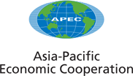
__________________________________________________________________________________________
2007/IPEG/001rev2
Agenda Item: 2

Annotated Agenda

Purpose: Consideration

Submitted by: Chair

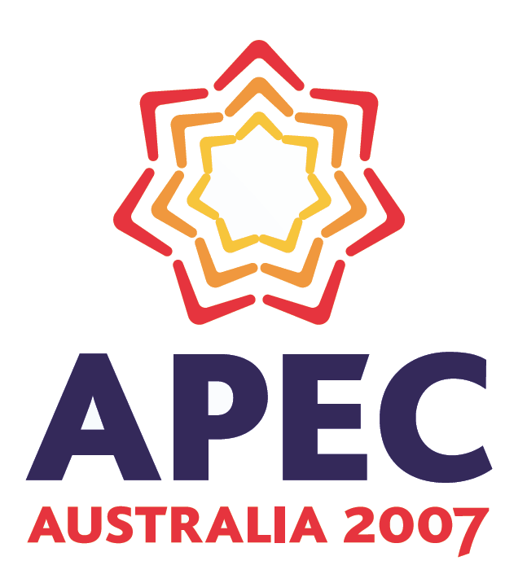 | 25th Intellectual Property Rights Experts’  Group Meeting  Taipei, Chinese Taipei  12–14 June 2007
APEC Intellectual Property Rights Experts Group
Taipei, Chinese Taipei
June 12 – 14, 2007

ANNOTATED AGENDA
(As of 11 June 2007)

June 12, 2007 9:00-17:00
June 13, 2007 9:00-17:00
June 14, 2007 9:00-12:00

- Opening
The Chair will open the IPEG XXV meeting.

Welcome speech by Mr Fadah Hsieh, Vice Minister of the Ministry of Economic Affairs.

- Adoption of the Agenda

- Report on Previous Activity of IPEG
Any member who wishes to identify its interests and to make presentations on them will be invited to do so.

3.A APEC

- APEC Secretariat Report on APEC Developments.

- The USA will present a verbal report on the APEC SME Working Group seminar held in Bangkok, May 8-10 2007.

3.B TILF

- Singapore will present an update on the APEC Project ‘APEC IPR Public Education and Awareness Market Research Best Practices’ (CTI 12/2007T).

3.C Self –funded

- Chile would like to inform the progress of the project "APEC-IPEG Survey on Copyright Limitations and Exceptions"

3.D Other

- Interactions with the CTI

- CTI priorities

- China will make a presentation on the draft Guidelines on Strengthen Capacity Building.

- China will give a presentation on “APEC-IPEG Survey on Practices of IPR Protection in Standardization”.

5-A. WTO Matters
Deepening the Dialogue on Intellectual Property Policy – WTO Doha Development Agenda and Protection of IPR in New Fields (Lead Economy: Convenor)

5-A-i. WTO Doha Development Agenda
Any member who wishes to identify its interests and to make presentations on them will be invited to do so.

5-A-ii. Protection of Emerging Fields in IPR
Any member who wishes to identify its interests and to make presentations on them will be invited to do so.

- Recent Development in the Protection of the Computer-implemented Inventions and Semiconductor Layout Design (Presentation by Korea)

- Protection of copyright in broadcasts in Australia (Presentation by Australia)

5-A-ii-a. Protection for Geographical Indications (Lead Economy: Mexico)
Any member who wishes to identify its interests and to make presentations on them will be invited to do so.

- Proposal – "Draft Template of Geographical Indications in APEC Economies". (Document by Mexico for consideration)

- Trademark Protection for Geographical Indications – US model (Presentation by the USA)

5-A-ii-b. Protection of Genetic Resources, Traditional Knowledge and Folklore
Any member who wishes to identify its interests and to make presentations on them will be invited to do so.

- New Zealand to update on the operation of the Maori Trade Marks Advisory Committee

5-B. Trade and Investment Facilitation
5-B-i. APEC Anti-Counterfeiting and Piracy Initiative (Lead Economy: Japan, Korea and USA)

- United States to update progress on developing Best Practices Paper on Innovative Techniques for IPR Border Enforcement

- United States to update progress on developing text on well-known counterfeit markets for Leaders Declaration

- United States update progress on developing text on signal piracy text for the MRT and/or AMM

- The United States and Japan to update on progress achieved by economies’ completing implementation templates for the first three sets of IPR Guidelines adopted under the 2005 Anti-counterfeiting and Piracy Initiative

- China will give a presentation on “China’s Measures to Combat Piracy.”

- Progress Report – Templates of IPR websites and Point of Contact (Information paper by Japan)

5-B-ii. APEC IPR Service Center (Lead Economy: Japan)
Any member who wishes to identify its interests and to make presentations on them will be invited to do so.

- IPR Service Center Progress Report (Information paper by Japan)

5-B-iii. Enforcement Related Activities
Any member who wishes to identify its interests and to make presentations on them will be invited to do so.

- Japan will make a presentation on “Proposal for international cooperation for IPR protection among enforcement agencies of APEC economies”

- Chinese Taipei will make a presentation on “Border Enforcement”.

- Mexico to update progress on Piracy and Anti-counterfeiting activities. (Document by Mexico for information)

- China will make a presentation on “China-US Customs' Memorandum of Cooperation on IPR border enforcement.

- Carriage Service Provider Liability under Australian copyright law (Information paper by Australia)

5-B-iv. Exchange of Information concerning New IPR Measures
Any member who wishes to identify its interests and to make presentations on them will be invited to do so.

- Chinese Taipei will make a presentation on “Establishment of IP Court”.

- China will make a presentation on “China’s plan on IPR Protection Action 2007”.

- Update on Vietnam IP system (Presentation by Vietnam)

5-C. Implementation of Pathfinder Initiatives
Any member who wishes to identify its interests and to make presentations on them will be invited to do so.

5-D. Implementation of Transparency Standards
Any member who wishes to identify its interests and to make presentations on them will be invited to do so.

- China will make a presentation on “the improvement of the transparency standards in trademark registration of China”.

5-E. Regional Trade Agreements (RTAs) / Free Trade Agreements (FTAs)
Any member wishing to share experiences in negotiations and other aspects of RTAs/FTAs will be invited to do so.

- Revised FTA/RTA Matrix (Inputs from Australia)

- APEC IPEG FTA/RTA matrix (Inputs from Japan)

- Other collective actions of IPEG
6-A. Support for Easy and Prompt Acquisition of Rights

- Japan will present update on “APEC Cooperation Initiative on Patent Acquisition Procedures.”

- KIPO's cooperation on Patent Acquisition Procedure (Presentation by Korea)

6-A-i. Establishing Internationally Harmonized IPR Systems (Lead Economy: Japan)
Any member who wishes to identify its interests and to make presentations on them will be invited to do so.

6-A-ii. Cooperation on Searches and Examinations (Lead Economy: Japan)
Any member who wishes to identify its interests and to make presentations on them will be invited to do so.

- Project between Mexico, Central America and Dominican Republic regarding the Establishment of a Mechanism for Searches and Examination of Patent Applications. (Document by Mexico for Information)

6-A-iii. Well-known Trademarks (Lead Economy: Thailand)
Any member who wishes to identify its interests and to make presentations on them will be invited to do so.

6-A-iv. Non-traditional Trademarks (Lead Economy: Singapore)
Any member who wishes to identify its interests and to make presentations on them will be invited to do so.

- Chinese Taipei will make a presentation on “Introduction of Non-Traditional Trademarks”.

- Singapore will present a verbal update on the project.

6-A-v. Plant Variety Protection Survey (Lead Economy: Singapore)
Any member who wishes to identify its interests and to make presentations on them will be invited to do so.

- Chinese Taipei will make a presentation on “Plant Variety Protection”.

- Singapore will present a verbal update on the project.

- APEC IPEG Survey on PVP (Information paper by Australia)

6-B. Electronic Processing of IPR-related Procedures
6-B-i. Electronic Filing Systems (Lead Economy: USA)
Any member who wishes to identify its interests and to make presentations on them will be invited to do so.

6-B-ii. Dissemination of Information by Electronic Means: APEC IPEG Website (Lead Economy: Australia)
Any member who wishes to identify its interests and to make presentations on them will be invited to do so.

- Proposed future of the APEC IPEG website (Presentation by Australia)

6-C. IP Utilization
6-C-i. Promoting IP Asset Management in APEC Economies (Lead economy: USA)
Any member who wishes to identify its interests and to make presentations on them will be invited to do so.

- Thailand will propose draft text on IP utilization for inclusion in the 2007 Leaders’ Declaration.

- “Developments in Intellectual Asset Management in Hong Kong, China” (Information Paper by Hong Kong, China)

- Chinese Taipei will make a presentation on “Promoting Intellectual Property Management System of Enterprise”.

6-C-ii. Raising Public Awareness (Lead economies: Australia and Hong Kong, China)
Any member who wishes to identify its interests and to make presentations on them will be invited to do so.

- Chinese Taipei to update on public awareness activities. (DVD presentation)

- Chinese Taipei will make a presentation on “IP Professional Training”.

- Mexico’s Efforts to Raise IP Public Awareness. (Document by Mexico for Information)

- Public Awareness Campaigns in the US (Information paper by the USA)

- New Project Proposals
Any member who wishes to identify its interests and to make presentations on them will be invited to do so.

- Raising Awareness and Providing Policy Insights on access to genetic resources and protection of traditional knowledge in APEC Economies (Presentation by Peru)

- APEC IPR Public Education and Awareness Campaign for SMEs (Presentation by Australia)

- APEC IPEG Survey on Opposition Proceedings (Presentation by the USA)

- Intellectual Property Rights Issues in Relation to Technical Standards Setting in the Digital Economy: Proposal for an APEC-IPEG Seminar on Practices among APEC Economies (Presentation by China)

- Cooperation with Other Fora / Bodies
Any member and guests who wishes to identify its interests and to make presentations on them will be invited to do so.

- Japan will make a presentation on HRDWG new project “IPR Strategies for Emerging Enterprises”.

- Technical Co-operation implemented by the EPO in Asia (Presentation by ECAP II).

- APEC Secretariat will present a project from the APEC Agriculture Technical Cooperation Working Group (ATCWG).

- Other Business
Any member who wishes to identify its interests and to make presentations on them will be invited to do so.

- “Amendments to the Patents Ordinance” (Information Paper by Hong Kong, China)

- “Recent Court Decision on Online Piracy” (Information Paper by Hong Kong, China)

- Request by Dr P Ganguli, CEO, VISION-IPR, to reproduce APEC-IPEG report “Geographical Indications – Compilation of the Questionaire”

- Document Access
Members will decide whether each document is to be made public or to be restricted.

- Future Meetings

- Peru has offered to host the 2008 IPEG meetings in Peru at the margins of SOM I and SOM III.

- Report to the Next CTI

