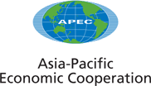

2007/MRM3/009
Agenda Item: 7

Implementation of APEC Mining Policy Principles and APEC Mining Working Group Action Plan

Purpose: Consideration
Submitted by: MRM3 Secretariat

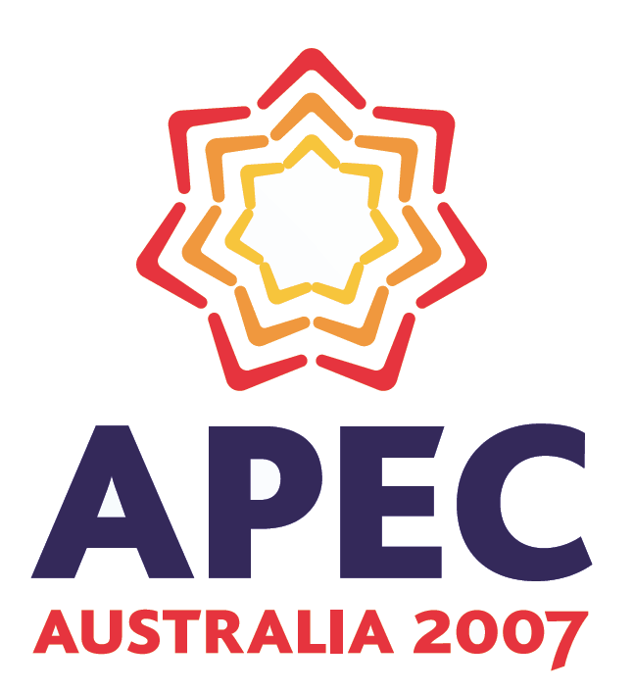 | Ministers Responsible for Mining Meeting  Perth, Australia  14 February 2007

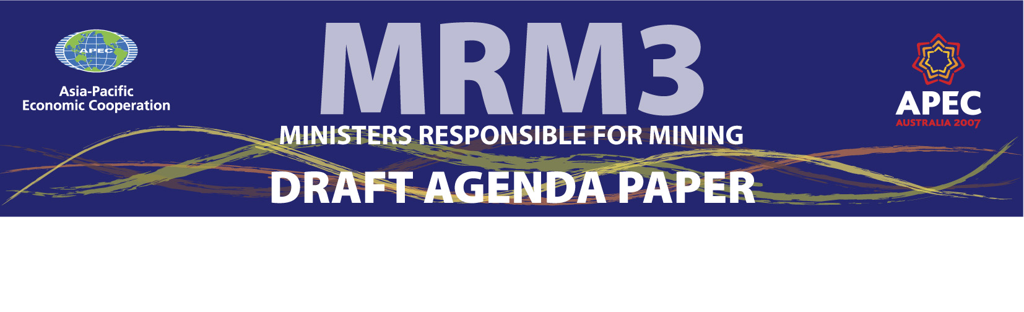
IMPLEMENTATION OF APEC MINING POLICY PRINCIPLES
OBJECTIVE:
To ensure that the Ministers Responsible for Mining Dialogue remains meaningful and achieves it objectives, through agreement to a set of non-binding Policy Principles.

RECOMMENDATION:
That Ministers note that:
- The Asia Pacific region is the main driver of global economic growth and a significant producer and user of minerals and metals;
- Many economies derive important economic and social benefits from their development, trade and use;
- The mining and metals industry can effectively be an engine for development;
- Resource endowment and minerals and metals usage varies considerably between APEC member economies; making the relationship among MRM economies more necessary;
- The meeting of Ministers Responsible for Mining provides Ministers with the opportunity to discuss the challenges arising for both producer and consumer economies from the increasing demand for minerals and metals globally, and the development of new technologies and applications which require new material; and

That Ministers agree to:
- The attached set of 10 non-binding Policy Principles;
- The establishment of an APEC Mining Working Group to progress the work and outcomes of MRM3 to report to Ministers at MRM4; and
- The attached Mining Working Group Action Plan, revised from the GEMEED Work Plan agreed by Ministers in 2005 at MRM2. Through the Action Plan officials will identify new or emerging issues and bring them to Ministers attention. Ministers will set the priorities, approve the Action Plan and endeavour to provide resources to allow officials to carry out the establishment of the Mining Working Group and related APEC activities.

Draft APEC Mining Policy Principles

APEC Pillar: Trade & Investment Facilitation
GLOBAL SUPPLY AND DEMAND

Market Trends and Transparency
- Pursue policies that enhance the sustainable production, trade and consumption of minerals and metals thereby improving the economic and social wellbeing of our people.
- Foster regular exchange between member economies about experiences with regulations, policies and practices and about significant developments in each economy's minerals and metals sector.
- Promote the best possible functioning of global markets for minerals and metals, through support for market transparency and facilitation of trade. Export restrictions should be employed only in exceptional cases, and in accordance with WTO rules.
- Foster investment certainty in the APEC minerals sector through the pursuit of open minerals and metals markets and the articulation of clear and predictable investment policies.
APEC Pillar: Business Facilitation
EFFECTIVE GOVERNANCE

Regulatory approaches and mining sector Initiatives
- Promote cost effective, evidence based, transparent and objective-based measures which improve the efficiency in the regulation of the minerals industry to contribute to economic, environment and social development outcomes.
- Encourage, support and promote initiatives by the minerals and metals industry and stakeholders that contribute to national and international sustainable development goals.
- Encourage research to develop and apply new minerals exploration, extraction, and pollution control technologies that are more cost effective, efficient, economically sound, environmentally responsible and socially acceptable. Promote information exchange and cooperation on such technologies.
APEC Pillar: Economic & Technical Cooperation
SUSTAINABLE DEVELOPMENT - IMPLEMENTATION

Life Cycle Partnerships and Capacity Building
- In partnership with all life cycle participants, ensure that materials and products made from minerals and metals are produced, consumed, recycled or disposed of in a responsible manner.
- Encourage all participants in the life cycle of a material or product to take direct responsibility for their area of action, and a shared concern over other stages of the life cycle.
- Support capacity building activities for sustainable development so that all APEC Economies are able to maximise the benefits and minimise the impacts from minerals resource development.

APEC Mining Working Group – Action Plan

APEC Pillar: Trade & Investment Facilitation

Policy Principles:

- Pursue policies that enhance the sustainable production, distribution and consumption of minerals and metals.
- Foster regular exchange between APEC economies about their experience with regulations, policies and practices and about significant activities in each economy's minerals and metals sector.
- Promote the best possible functioning of global markets for minerals and metals through support for stable supply of and demand for minerals and metals, market transparency and facilitation of trade.
- Foster investment certainty in the APEC minerals sector through the pursuit of open minerals and metals markets and the articulation of clear and predictable investment policies.

Implementation Strategies:
- Improve the flow and exchange of information and experiences in the mining, metals and related energy industries;
- Improve regulatory and legal regimes relevant to minerals, metals and related energy trade and investment; and
- Monitor and react to international regulatory initiatives (e.g., EU, OECD, SAICM, UNEP) targeting the trade in and use of minerals, metals and related energy.

Key Actions:
- Demonstrate the contribution of minerals, metals and related energy industries to sustainable development
- Governments and industry better communicate the benefits of mining to their citizens to improve society’s appreciations of the mining and metals industry
- Assess trade and investment regimes relevant to minerals, metals and energy in APEC economies
- Share knowledge of trade and investment leading practices and good experiences
- Assess the impact of the proposed international regulatory initiatives on APEC economies
- Share assessments of potential impacts of proposed legislations and communicate concerns to relevant organisations
- Share information on international regulatory initiatives, discuss possible impacts and responses

Performance Measures:
- Sharing of expertise to compile relevant statistics
- Mines Ministries prepare information packages detailing the economic and social benefits from mining.
- Regulatory and legal regimes relevant to trade and investment assessed and actions identified.
- Minerals, metals and associated energy concerns related to proposed international regulatory initiatives are discussed with relevant officials

Outcomes:
- Citizens of APEC Economies have access to up-to-date and reliable information about the contribution mining, minerals and metals make to their national economies
- Avoidance of unnecessary regulation on minerals and metals
- Improved trade and investment in exploration, mining and metals and related energy industries among the APEC economies

APEC Pillar: Business Facilitation

Policy Principles:

- Promote cost effective, transparent and objective-based measures which improve the efficiency in the regulation of the minerals industry to contribute to sustainable development outcomes.
- Encourage, support and promote initiatives by the minerals and metals industry and stakeholders that contribute to national and international sustainable development goals.
- Encourage research to develop and apply new minerals exploration and extraction technologies that are more cost effective, efficient, economically sound, environmentally responsible and socially acceptable.

Implementation Strategies:
- Integrate sustainable development considerations within corporate and government decision making processes
- Improve transparency of technical standards and legal/regulatory compliance regimes in the region
- Examine mechanisms to work more closely with the industry
- Improve the workforce capability, including the capacity of indigenous people to contribute to mining operations

Key Actions:
- Analysis of degree of mutual recognition of standards and duplicative conformity assessment arrangements
- Regulatory frameworks: Commitment to publish mining laws; and share leading practice in mining regulatory regimes
- Mining data: commitment to improve transparency of mining related information e.g. geological and statistical data
- Engage with the APEC Mining Industry Forum (MIF)
- Engage with the APEC Business Advisory Council (ABAC)
- Maintain collaboration and information exchange with the NFMD
- Assess and evaluate the current situation of the workforce resources in the mining and metals industry in APEC economies
- Support the development of mining related small and medium enterprises

Performance Measures:
- Improved efficiency and reduced cost in meeting standards and compliance regimes
- Mining regulations are available on government websites (in English and local language)
- Creation of an APEC business network which allows cooperation among its members, as well as the analysis of new opportunities for minerals, metals and its related sectors within the APEC region
- Reduction in skilled labour shortages

Outcomes:
- Greater transparency in standards and compliance regimes in the APEC region
- Greater regulatory and mining data transparency
- Enhanced communication between governments and industry
- Improved access to skilled workers

APEC Pillar: Economic & Technical Cooperation

Policy Principles:
- In partnership with all life cycle participants, ensure that materials and products made from minerals and metals are produced, consumed, recycled or disposed of in a responsible manner.
- Encourage all participants in the life cycle of a material or product to take direct responsibility for their area of action, and a shared concern over other stages of the life cycle.
- Support capacity building activities so that APEC Economies are able to maximise the benefits and reduce the impacts from minerals resource development.

Implementation Strategies:
- Support international financing for mining industry.
- Promote cooperation of scientific and technological research and development in minerals, metals and related energy industries, within the framework of APEC-ECOTECH principles
- Seek continual improvement of environmental performance of minerals, metals and related energy sectors and related regulatory regimes
- Seek continual improvement of health and safety performance in the minerals, metals and related energy sectors and related regulatory regimes
- Promote energy efficiency and conservation in mining
- Promote the exchange of professionals and researchers among APEC economies
- Promote links between the International Finance Institutions, and the APEC Authorities Responsible for Mining.
- Promote better practices in project development, considering governance, transparency and sustainable development

Key Actions:
- Share leading practice and where appropriate develop frameworks to address environmental performance regimes; health and safety performance regimes; and energy efficiency and conservation in mining
- Conduct workshops, disseminate information on leading practice in sustainable development.
- Exchange of information with other groups and agencies (e.g., World Bank, UNCTAD)
- Encourage mutual recognition of professional and academic standards by national professional bodies

Performance Measures:
- Mines Ministries prepare information packages detailing the economic and social benefits from mining.
- Workshops held to discuss these issues.
- World Bank and UN officials invited to participate in GEMEED workshops and meetings
- Continued dialogue with the international finance institutions
- Improved governance and transparency in support projects

Outcomes:
- Enhanced economic and technical cooperation between economies
- Raised awareness of approaches to mitigate environmental and social impacts of mining
- Improved integration of sustainable development principles in the APEC mining sector.
- Citizens of APEC Economies have access to up-to-date and reliable information about the contribution mining, minerals and metals make to their national economies

