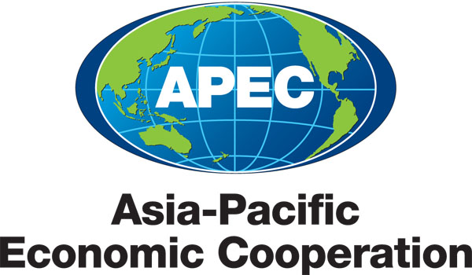
___________________________________________________________________________
2010/SOM3/EC/SEM/000

Document List

Submitted by: APEC Secretariat

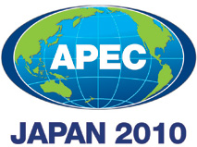 | Seminar on Getting Credit for Small and Medium Enterprises  Sendai, Japan  21 September 2010

Document List

Document No. | Title | Session | Submitted By
2010/SOM3/EC/SEM/000 | Document List - Seminar on Getting Credit for Small and Medium Enterprises 2010 |  | APEC Secretariat
2010/SOM3/EC/SEM/001 | Agenda - Seminar on Getting Credit for Small and Medium Enterprises 2010 |  | Japan
2010/SOM3/EC/SEM/002 | Speakers and Moderators |  | Japan
2010/SOM3/EC/SEM/003 | Doing Business: Getting Credit and APEC | 1 | World Bank
2010/SOM3/EC/SEM/004 | Impacts of People’s Republic of China (PRC) bankruptcy Law on Safeguarding Investments and Claims | 1 | King & Wood
2010/SOM3/EC/SEM/005 | How Information Sharing Can Improve Access to Finance for Small Micro and Medium-Sized Enterprises (SMMEs): Some Lessons for APEC Economies | 1 | Policy and Economic Research Council (PERC)
2010/SOM3/EC/SEM/006 | Problems Facing Small and Medium-Sized Enterprises (SMEs) How APEC Economies Can Better Address These Issues Going Forward | 2 | Proactive Corporation
2010/SOM3/EC/SEM/007 | The Role of Collateral and Government Assistance in Small and Medium-Sized Enterprise (SME) Financing: The Case of Japan | 2 | Japan
2010/SOM3/EC/SEM/008 | Issues Particular to Small and Medium-Sized Enterprise (SME) Assistance for Women Entrepreneurs | 2 | Mexico
2010/SOM3/EC/SEM/009 | APEC Business Advisory Council’s (ABAC) Work Related to Getting Credit for Small and Medium Enterprises | Luncheon | ABAC
2010/SOM3/EC/SEM/010 | Legal Infrastructure for Promoting Small and Medium-Sized Enterprise (SME) Finance | 3 | APEC FMP
2010/SOM3/EC/SEM/011 | The Development of Small and Medium-Sized Enterprise (SME) Credit Information Database to Promote SME Lending | Luncheon | Keio University
2010/SOM3/EC/SEM/012 | Discussion Paper for Breakout Discussion Session | 3 | Japan

