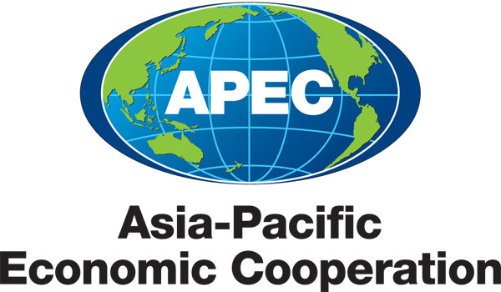
___________________________________________________________________________
2011/MAG/WKSP2/001

Programme

Submitted by: Brunei Darussalam

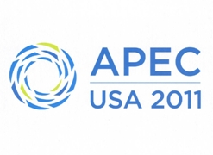 | Self-Certification Pathfinder Phase 2: Capacity Building Workshop 3  Bandar Seri Begawan, Brunei Darussalam  4–5 April 2011

APEC Self-Certification Pathfinder Phase 2:
Capacity Building Workshop 3
(CTI 41/2010A)
04 – 05 April 2011
Radisson Hotel, Bandar Seri Begawan, Brunei Darussalam

Day 1 (Monday, 04 April)
Time | Activity
8:30 - 9:00 am | Arrival /Registration
9:00 - 9:15 am | Welcoming of Participants/Opening Address  [Dato Lim Jock Hoi, Permanent Secretary, Ministry of Foreign Affairs & Trade]
9:15 - 10:10 am | SESSION 1: Introduction to Self-Certification  Overview on self-certification, including models  Moderated by: [Abu Sufian Hj Ali, Director of International Trade, Ministry of Foreign Affairs & Trade]  - Introduction to the APEC Self-Certification Pathfinder Operating Guidelines (20 min)  [Mr. Tan Juan Fook, Singapore Customs]  - Singapore’s Experience in Self Certification of Origin (20 min)  [Mr. Tan Juan Fook, Singapore Customs]  Q&A session (15 min)
10.10 - 10.40 am | Coffee Break
10:40 am - 12:00 pm | SESSION 2: Advantages and Difficulties Experienced by Businesses, Including from Small and Medium Enterprises, in Utilising Self-Certification Regimes  Overview on experiences of businesses in utilizing Self-Certification Regimes  Moderated by: [Hajah Johariah Haji Abdul Wahab, Director of Trade Development, Ministry of Foreign Affairs & Trade]  - Self-Certification from the Certifier’s Perspective: Private Sector’s Perspective, Challenges and Difficulties; and E-origin (1 hour)  [Mr. Brian Staples, Canada]  Q&A session (15 min)
12:00 - 1:30 pm | LUNCH BREAK
1:30 - 2.45 pm | SESSION 3: Legal and Institutional Mechanisms to Support a Self-Certification Regime  Supporting domestic legislation and enforcement mechanisms that are necessary to ensure integrity of the self-certification system  Moderated by: [Haji Ibrahim Hj Abd Rahman, Royal Customs and Excise Department, Ministry of Finance]  - Approved Exporter Self Certification System (Experience of Japan) (30 min)  [Mr. Koichi Okada, Japan’s Customs]  - Mechanisms to Support Self-Certification System (30 min)  [Mr. Mark Collidge, Australia’s Customs]  Q&A session (15 min)
2:45 - 3.05 pm | COFFEE BREAK
3:05 - 5:05 pm | SESSION 4 (Break out): Government and Private Sector  Participants to break out into two (2) groups and discuss the assigned topics for each group. At the end of each session, both groups should come up with recommendations that will be shared in the common session the following day.  GOVERNMENT SESSION: The Regulator’s Options  Key considerations that guided each economy’s choice of Self-Certification model, comparison of legislation and enforcement mechanisms, and strategies and recommendations to overcome key challenges  Moderated by: [Hajah Johariah Haji Abdul Wahab, Director of Trade Development, Ministry of Foreign Affairs & Trade]  PRIVATE SECTOR SESSION: Self-Certification – A Business Perspective  Feedback, including from private sector on expectations/experiences in utilizing self-certification regimes, and recommendations for the government to overcome challenges.  Moderated by: [Vincent Kong, Director of Economic Cooperation, Ministry of Foreign Affairs & Trade]
End of Day 1

Day 2 (Tuesday, 05 April)
Time | Activity
8:30 - 9:00am | Arrival/Registration
9:00 - 10:30 am | SESSION 5: Sharing of Results and Recommendations  Representatives from each group will report the results and recommendation for each session. Each representative will be given 30 minutes to discuss. A Q&A session will take place after the discussion.  Moderated by: [Monica Contreras Rosales, APEC CTI Chair]  Q&A session (30 min)
10:30 - 11:00 am | COFFEE BREAK
11:00 - 11:30 am | Overall Q&A session and Wrap-up
11:30 - 11:40 am | Closing Remarks  [Monica Contreras Rosales, APEC CTI Chair]
11:40 - 11.55am | Group photo session
End of the Workshop

