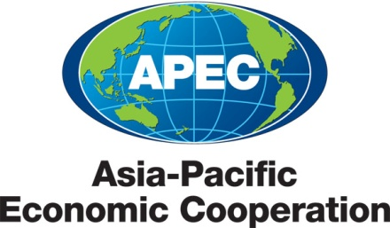
___________________________________________________________________________
2011/MAG/WKSP3/000

Document List

Submitted by: APEC Secretariat

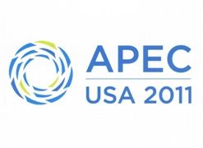 | Self-Certification Pathfinder Workshop  Ha Noi, Viet Nam  28-29 July 2011

Document List

Document No. | Title | Submitted By
2011/MAG/WKSP3/000 | Document List – Self-Certification Pathfinder Workshop 2011 | APEC Secretariat
2011/MAG/WKSP3/001 | Agenda – Self-Certification Pathfinder Workshop 2011 | Viet Nam
2011/MAG/WKSP3/002 | Introduction to Self-Certification Common Operating Guidelines | Malaysia
2011/MAG/WKSP3/003 | Singapore’s Experience in Self Certification of Origin | Singapore
2011/MAG/WKSP3/004 | Self–Certification: Advantages and Difficulties for a Developing Economy | Viet Nam
2011/MAG/WKSP3/005 | Self Certification System in Japan | Japan
2011/MAG/WKSP3/006 | Updates on ASEAN Self-Certification Pilot Scheme | Malaysia
2011/MAG/WKSP3/007 | Relationships of Competent Authorities and End Users of Self-Certification - Requirements and Responsibilities of Exporters / Manufacturers | New Zealand
2011/MAG/WKSP3/008 | Relationships of Competent Authorities and End Users of Self-Certification - Cooperation and Partnership Between Designated Competent Authorities and Processing Authorities | New Zealand
2011/MAG/WKSP3/009 | United States Importer-Based Self-Certification System | United States
2011/MAG/WKSP3/010 | Verifications Under a Self-Certification Regime | Canada
2011/MAG/WKSP3/011 | Risk Management Under a Self-Certification System | Canada
2011/MAG/WKSP3/012 | Legal and Institutional Mechanisms to Support a Self-Certification Regime | United States
2011/MAG/WKSP3/013 | Laws and Regulations on Self-Certification | Malaysia

