+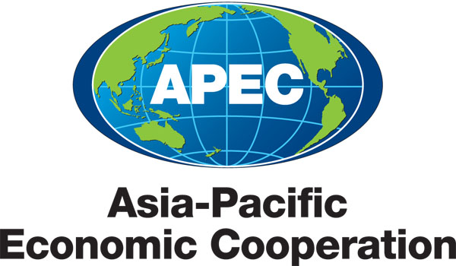
___________________________________________________________________________
2012/CTI/WKSP/000

Document List

Submitted by: APEC Secretariat

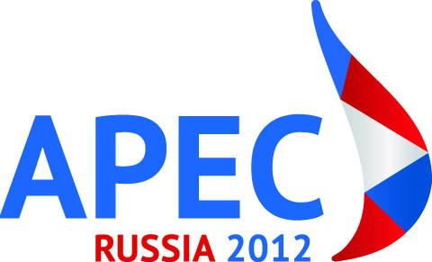 | Workshop on Increasing Free Trade Agreement Utilization by SMEs  Tokyo, Japan  7 August 2012

Document List

Document No. | Title | Session | Submitted By
2012/CTI/WKSP/000 | Document List - Workshop on Increasing Free Trade Agreement Utilization by SMEs 2012 | - | APEC Secretariat
2012/CTI/WKSP/001 | Agenda - Workshop on Increasing Free Trade Agreement Utilization by SMEs 2012 | - | Japan
2012/CTI/WKSP/002 | Speakers’ List | - | Japan
2012/CTI/WKSP/003 | Opening | Opening | Japan
2012/CTI/WKSP/004 | Benefits of Free Trade Agreements for SMEs | 1 | Waseda University
2012/CTI/WKSP/005 | Free Trade Agreement Use by SMEs: Evidence from Asia | 1 | Asian Development Bank Institute
2012/CTI/WKSP/006 | Free Trade Agreement Benefits and Challenges for SMEs | 1 | White & Case LLP
2012/CTI/WKSP/007 | Japan’s Efforts to Encourage SMEs to Utilize Economic Partnership Agreements (EPAs) | 2 | Japan
2012/CTI/WKSP/008 | Free Trade Agreement Process and Outreach Strategy - Singapore | 2 | Singapore
2012/CTI/WKSP/009 | SMEs’ Best Practices of Free Trade Agreement Utilization and Korea Customs Service Outreach Program | 2 | Korea
2012/CTI/WKSP/010 | Peru: Increasing Free Trade Agreement Utilisation by SMEs | 2 | Peru
2012/CTI/WKSP/011 | Free Trade Agreement Utilization and How to Support SMEs | 2 | Viet Nam
2012/CTI/WKSP/012 | Free Trade Agreement Utilization Policy - Korea | 2 | Korea
2012/CTI/WKSP/013 | Best Practices on Free Trade Agreement Promotion Policies - Philippines | 2 | Philippines
2012/CTI/WKSP/014 | Best Practices on Free Trade Agreement Promotion Policies - Thailand | 2 | Thailand
2012/CTI/WKSP/015 | Support SME Globalization | 3 | Tokyo Chamber of Commerce and Industry
2012/CTI/WKSP/016 | Baker and McKenzie's Approach: Strategic Partnership with the United States Commercial Service and Assisting Clients in Utilizing Free Trade Agreements | 3 | Baker and McKenzie
2012/CTI/WKSP/017 | Increasing Free Trade Agreement Utilization by SMEs | 3 | Canadian Chamber of Commerce

