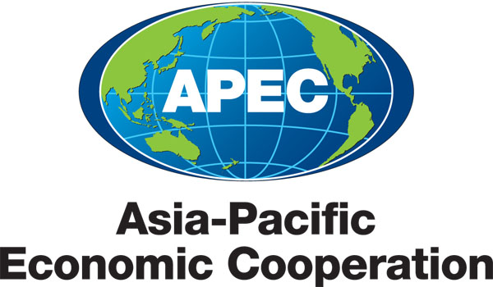
__________________________________________________________________________________
2012/SOM2/PPFS/009

Price Volatility in Food Markets and Approaches to Mitigate it - Monitoring and Exchange of Information

Purpose: Information
Submitted by: Russia

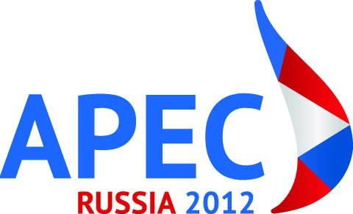 | Policy Partnership on Food Security Meeting  Kazan, Russia  28-29 May 2012

Price Volatility in Food Markets and Approaches to Mitigate it
Monitoring and Exchange of Information

Introduction

A growing number of people is experiencing food insecurity due to the rise in food prices in consequence of an increasing world population and the corresponding growth in demand for food with only a small increase of supply. The food price volatility can intensify the problem of food insecurity. In 2011 the FAO Food Price Index averaged 228 points exceeding its maximum value during the food crisis of 2007-2008. According to the OECD-FAO estimates, agricultural commodity prices will remain high and volatile until 2020, making it even more difficult to enhance food security.

Background

This issue was extensively discussed by the international community in 2011. Food price volatility was the main agenda item during the presidency of France at the G20 summit. For the first time, 10 major international organizations joined their efforts to make G20 recommendations. The document entitled: “Price Volatility in Food and Agricultural Markets: Policy Responses” contained not only a deep analysis of the reasons for the increase of prices volatility in agricultural products at the present stage, but also proposed a G20 Action Plan. The Plan provided for the elaboration of an international comprehensive strategy on sustainable agriculture, improvement of market information systems to reduce food price volatility and increase transparency, coordination of economies’ efforts to strengthen food security in the world. This issue was also discussed by the UN General Assembly, Economic and Social Commission for Asia and the Pacific (ESCAP), and the Food and Agriculture Organization of the United Nations (FAO).

FAO, with other relevant international organizations, who took over the concept of the G20 Paris Declaration convened High Level Panel of Experts on Food Security and Nutrition of the Committee on World Food Security (CFS) in October 2011, where the followings were discussed: disciplines on export restrictions; transparency of food stock information system such as Agricultural Market Information System (AMIS); etc.

The creation of a Rapid Response Forum to harmonize and coordinate policies during food crises was one of the specific decisions in this direction, along with the creation of AMIS. According to the Food Security Action Plan adopted in Niigata in 2010 Japan has developed the Asia-Pacific Food Security Information Platform (APIP) which will enable APEC economies to monitor, exchange and use up-to-date information on food production, supply and demand, and prices in the APEC region.

Proposals

The Russian Federation proposes:

- to consider joining the efforts of APEC member economies and G20 economies to reduce price volatility;
- to consider possibilities and areas of cooperation between AMIS and APIP, starting from establishing a functional linkage between the two systems, as well as possibilities of APEC economies who are not G20 or AMIS members to participate in two information systems;
- to consider possibilities of further development of a common information system in the context of expansion of functionality, accessibility, inclusion of more separate food markets (markets of specific commodity groups) into the system;
- to discuss ways to reduce and mitigate volatility in food prices including developing market-based risk management tools;
- to discuss a reasonable balance between the traditional and bio-energy production, the development of the so-called “second generation of bio-fuel technologies”, which use non-food materials for production of bio-fuel, particularly cellulose, animal wastes and solid household garbage, as well as biotechnological plants specially created for the use of plant residues for the efficient production of bio-fuel after harvesting;
- to discuss agricultural financial markets transparency at meetings of the APEC Ministers of Finance;

- to discuss an issue of involving the Consultative Group on International Agricultural Research (CGIAR), the International Rice Research Institute in Philippines, UN Food and Agriculture Organization (FAO), as well as other APEC specialized research centers to be parts of this AMIS-APIP initiative within APEC economies.

