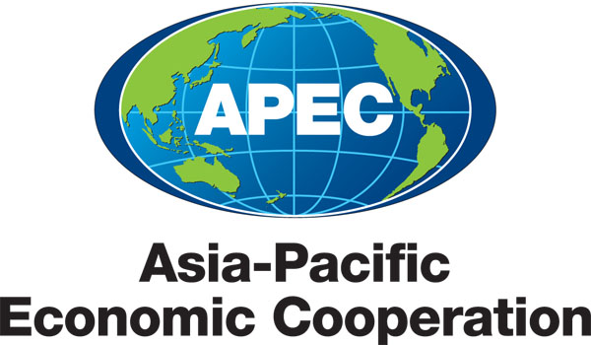

2013/SOM3/HRDWG/040
Agenda Item: EDNET 5.4

Project Completion Report: APEC Training Program for Preventive Education on ICT Misuse

Purpose: Information

Submitted by: Korea

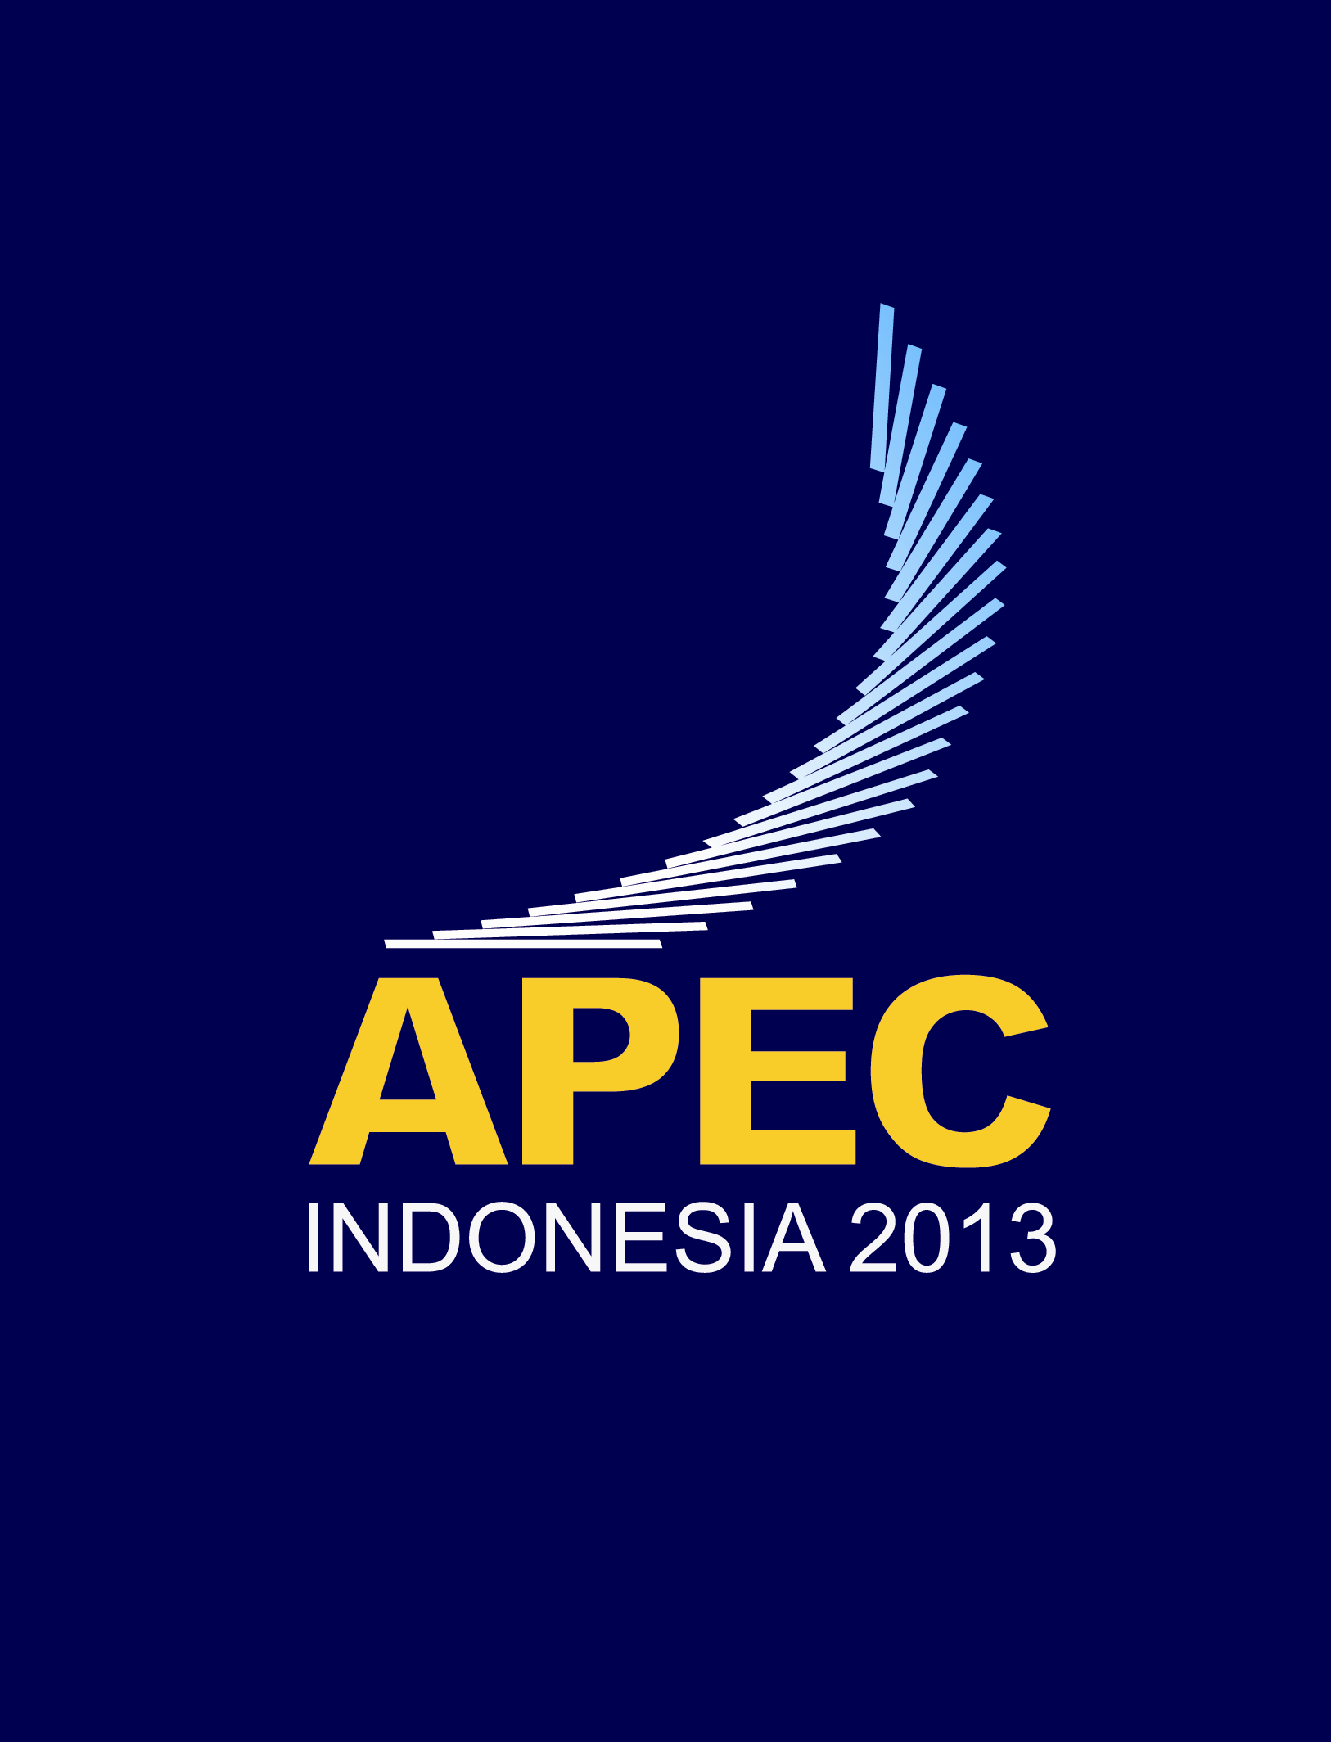 | 35th Human Resources Development Working Group Meeting  Medan, Indonesia  24-26 June 2013

Project Completion Report of
‘APEC Training Program for Preventive Education on ICT Misuse’
The 35th HRD Working Group Meeting
EDNET
June 24-25, 2013
Medan, Indonesia
I. Background

As a joint project between TELWG and HRDWG, the project has been designed to disseminate the educational contents previously made by the ‘Education Program on Effective and Productive Utilization of ICT for Novice ICT Users and Early Learners’ project which was supported by APEC Education Foundation (AEF, Korea) and implemented by KT Cultural Foundation (KTCF, Korea) in 2008. Since every economy has different agendas and economic development level, the project contains specific strategies for each economy depending on their special features regarding the ICT misuse. As forming a training program through this project, it is highly expected to contribute in maximizing the preventive education on ICT misuse and to get evaluated and feedbacks on the educational materials from APEC member economies in order to provide them with the chances to make a full use of the revised one to share the prosperities.

II. Recent Progress

- Implementation of the fourth pilot training in Malaysia (March 2012)

Background

Malaysia, through the efforts of the Malaysian Communications and Multimedia Commission (MCMC), developed a campaign on Internet safety to educate net users in Malaysia. Printed materials on phishing and Internet banking and safety guidelines for young users were developed as part of the project. In 2012, Korea proposed collaboration with Malaysia to run the “APEC Training Programme for Preventive Education on ICT Misuse” to be held in Malaysia. Through close cooperation between institutions and agencies from Korea and Malaysia, the training program was successfully organized at MCMC’s office in Cyberjaya, Malaysia during the period 26 – 30 March 2012.

Objectives

- The objectives of this program were:
  - Gather, learn and compare major issues/cases of ICT misuse in the APEC region for greater comprehension of the problems
  - Exchange relevant training activities, promote a safe and trusted ICT environment and prevent misuse of ICT
  - Develop a more comprehensive and enhanced module for training and awareness programme throughout the year.

Activities

- Preparation (by schedule)

Date | Activities
April 2011 | Communications between MCMC and KTCF commenced. Discussions ensued via email between MCMC and Ms. Estelle Shim to discuss the program structure.
January 2012 | Scheduling, budget, and target participants of the program finalized.  Internal teams (cross department) consisting of members from Digital Security Management Department, Academy, International Affairs Dept and Outreach Division were formed.
February 2012 | Engagement of the Community Broadband Libraries (CBL)’s representative for ToT training commenced.  Ministry of Information, Communications and Culture (MICC) and Group of Universities Students (Kumpulan Rakan Siswa Malaysia or KARISMA) approached and agreement to arrange EUT participants secured.
15th March 2012 | Final meeting with Ms. Estelle Shim with all relevant stakeholders in MCMC to finalize the program, agenda, participants etc.

- Implementation

The programme was implemented over 5 days in 3 phases (back-to-back):

Phase 1 | Training of Trainers (ToT)  26 - 28 March 2012 (3 days)  No of Participants: 10 CBL instructors and 3 selected KARISMA representatives | During the ToT session, participants were trained on the module “Preventive Education on ICT Misuse” by representatives from MCMC and institutes from Korea.  Subsequently, participants were required to develop their own module by combining what they had learned in earlier sessions. During this session, participants became actively involved in designing End-users' training curriculum.  The programme also required ToT participants to use their own developed material in End-User Training modules.
Phase 2 | End- user training  29 March 2012 (1 day)  No of Participants: 43 university students across Malaysia | On the 4th day, participants from the ToT session made a trial run using the module developed earlier during the end-user training session.
Phase 3 | Debriefing Session  30 March 2012 (1 day) | The ToT participants who became trainers for the End user's training evaluated the entire programme during the last day of the session.
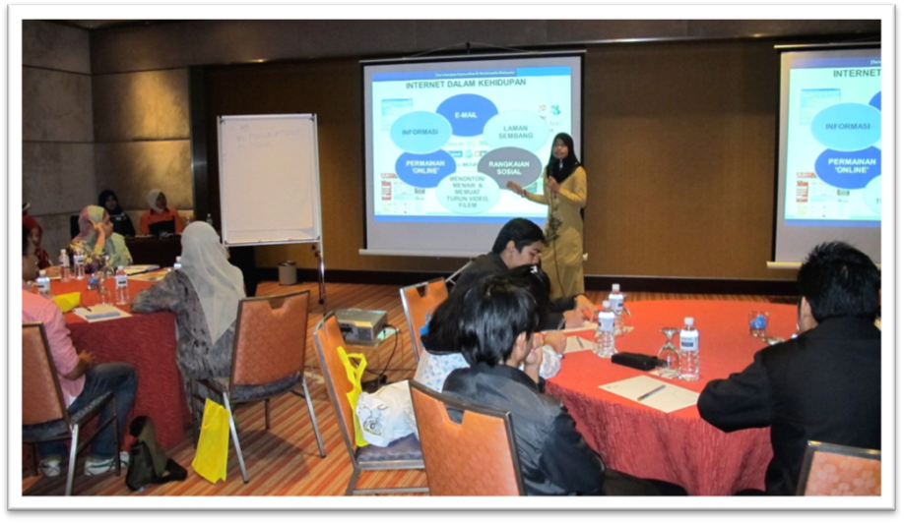
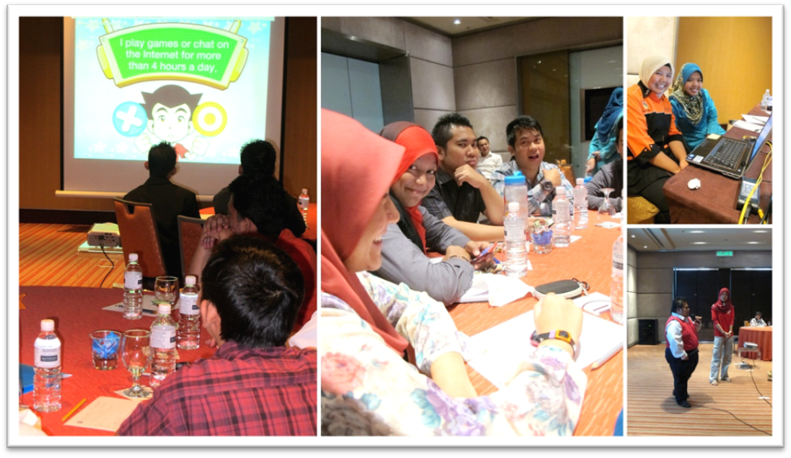
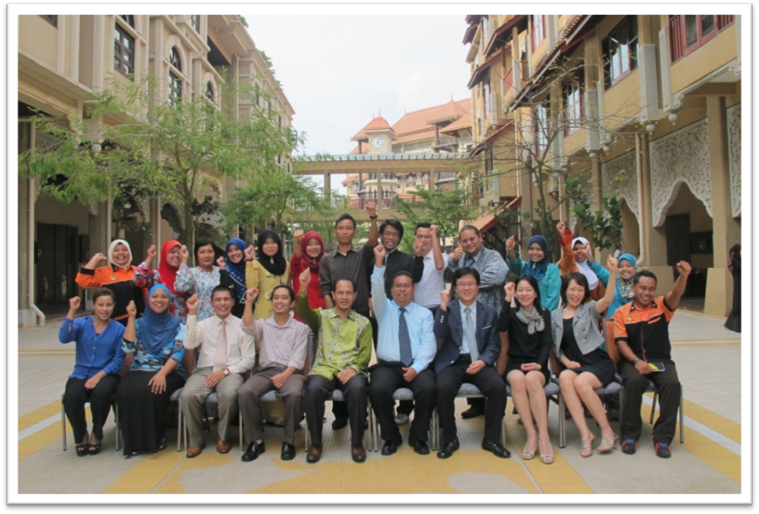
ToT Participants & Instructors

Upon the successful completion of the training programme, MCMC prepared a list of training programmes for 2012 to implement the training modules.

Activity | Objective and Topics | Date & venue | Participants
End-user Training –  General  Public | Objectives:  - Educate participants to understand the Internet and its use in their daily life  - Anticipate the negative effects of Internet misuse in participants’ daily life; and  - Urge participants to use the Internet constructively in their daily life  Topics:  - Internet Safety and Ethics  - Mobile Contents  - Business Opportunities over the Internet | On and off-line training from April to Nov 2012 | Targeted at least 11,000  Members of the general community

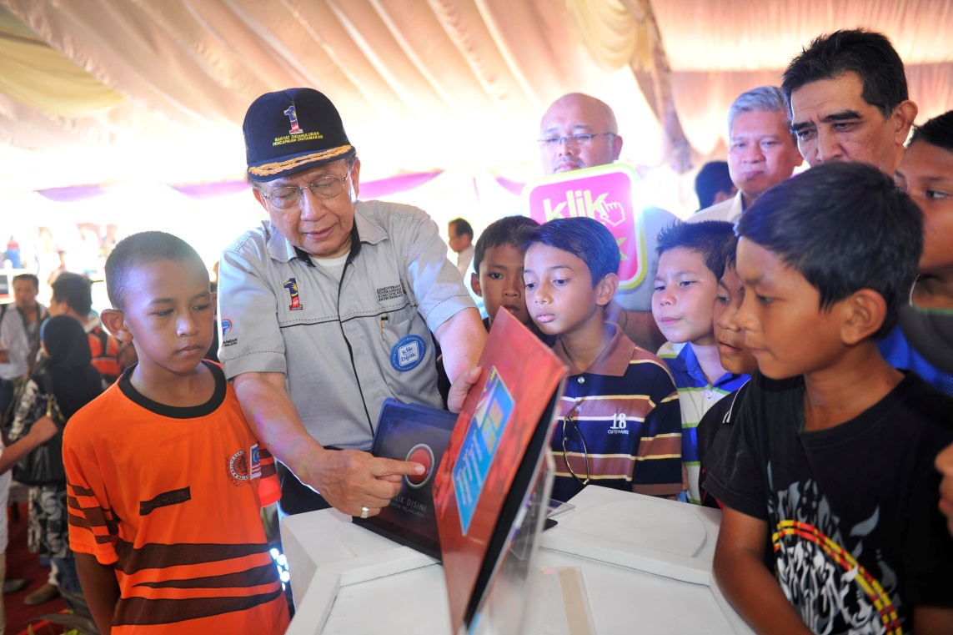
Launching of the “Klik dengan Bijak” campaign
by the Minister of Information, Communications and Culture

Throughout 2012, the MCMC invested great effort in promoting safer Internet use to the community. This culminated in the launching of “Klik dengan Bijak” (Click Wisely) Campaign nationwide on 1 July 2012 by the Minister of Information, Communications and Culture, H.E. Dr. Rais Yatim. The campaign was specifically designed for children, youth, parents and guardians.

The “Klik dengan Bijak” (or “Click wisely”) logo, selected as the tagline for this campaign, was used to serve as a reminder to users to be careful and think before they access and use the Internet. Furthermore, the term “Klik” (click) is an action applicable on all digital devices and various applications and is a term that can be easily be understood by all.

Amongst the key messages of the campaign were:
      - “Tips on protecting yourself online”;
      - “Dangers of fraud and scams online”; and
      - “Cyber threats”

Following the completion of the pilot ToT Session in Cyberjaya, MCMC continued the ToT Training programme using a enhanced module developed from the pilot session at four (4) other locations in Malaysia i.e. Johor, Melaka, Penang (Northern Region - Perlis, Perak, Penang and Kedah) and Sabah. More ToT trainings are schedule for 2013.

Benefits and Achievements

The implementation of the pilot project initiated by KTCF and APWINC together with MCMC has helped Malaysia prepare for the launch of “Klik dengan Bijak” on large scale implementation throughout the entire nation with the pilot project conducted in Cyberjaya.

Since the launching of KDB nationally, the campaign was featured in 136 events with an estimated audience of 61,440. Breakdown of the events are provided in the following table:

No. | Organizer | No. of events | Estimated audience
1. | Outreach and Engagement Division (ONE-D)/Regional Offices | 105 | 37,990
2. | Ministry and other agencies | 24 | 21,510
3. | NGOs and other organizations | 7 | 1,940

The campaign is expected to continue to grow and more material will be developed via online and offline channels.

Evaluation

The APEC Training Program for Preventive Education on ICT Misuse was a significant initiative by KTCF and APWINC in sharing information between member economies with regards to promoting a safer Internet to the users. The opportunity to experience and learn from each member assisted participants to develop and improve their own campaign.

For MCMC, the opportunity to work with KTCF and APWINC has been a valuable experience for the participants. Feedbacks collected from participants at the end of the training programme are indicated in the following table:
No. | Evaluation comments
 | Interesting and informative training sessions.
 | Useful training materials (PowerPoint, videos, guide books etc.) for information sharing with various target groups
 | Generic information other than Internet Safety such as SMS, short code, mobile usage and user issues in Malaysia were very informative for the participants.
 | Provided opportunity to learn and develop good presentation.
 | Improved confidence level of participants to be instructors.
 | Good facilities and smooth arrangement during the ToT session.

- Implementation of the fifth pilot training in Viet Nam (November 2012)

Background

Not only in Vietnam but also in many other countries, Internet addiction has been an alarming problem to the youth. It is a behavioral addiction in which a person becomes dependent on use of the Internet or online devices and is recognized as a maladaptive coping mechanism for stress. Internet addiction, especially game addiction, is becoming widely recognized and acknowledged, particularly in countries where it is affecting large numbers of people.

With the support of KTCF and APWINC, the Department of Information and Communications of Binh Dinh Province (affiliated with the Vietnam Ministry of Information and Communications) implemented the “APEC Training Program for Preventive Education on ICT Misuse” project during the period Nov-19-29, 2012..

Objectives

The main purpose of this project was to disseminate and customize developed educational materials for preventive education on ICT misuse as well as raise awareness on ICT preventive education in Vietnam.

Activities

1. Preparation schedule

Date | Task
September 21, 2012 | Preparation meeting with KTCF and APWINC
October 1, 2012 | Working with the Department of Education and Training, Department of Information and Communication, Department of Science and Technology, and Quy Nhon University concerning project implementation
October 10, 2012  - October 20th, 2012 | Budget planning
November 10, 2012 | Contract signing
November 12, 2012 | Sending letter of invitations
November 18, 2012 | Preparation checking

2. Implementation

The comprehensive training program was as follows;

Activity | Objective and Topics | Date & venue | Participants
Expert Group Workshop  (EWG) | Devise online end-user training workshop design and plan for the end-user training implementation | 19-23 Nov. 2012  Binh Dinh IT Center | 10 Experts from DIC, DST, DOET and QNU
Training of Trainers (TOT) |  | 25-27 Nov. 2012  Binh Dinh IT Center | 20 teachers from secondary schools
End-user Training  (EUT) | - Learn about advantages and disadvantages of game  - Prevent game addiction  - Netiquette in playing game  - Consider how to effectively protect personal information online  - Prevent cheating from others in on-line chatting  Topics covered:  - Game Addiction  - Protection of Personal Information | 28 Nov. 2012  3 secondary schools in Binh Dinh Province | 130 students
Debriefing | Evaluate the training program (experiences, challenges, lessons learned, good practices) and provide recommendations for subsequent steps | 29 Nov. 2012  Binh Dinh IT Center | 10 experts + 20 teachers

a. Experts Group Workshop - EGW (From November 19, 2012 to November 23, 2012):
Ten ICT experts and ICT teachers were invited to the workshop to review the Korean materials and select training topics. This group included ICT experts and teachers from the Department of Education and Training, Department of Information and Communication, Department of Science and Technology, and Quy Nhon University. During the 5-day workshop, the experts examined and discussed the provided materials, created teaching documents suitable for Vietnamese secondary students (including PPt files, animation files, video clips, software, multiple choices questions, etc). Furthermore, e-modules in the form of webpages was also created and made accessible (URL http://ict.stttt.binhdinh.gov.vn).

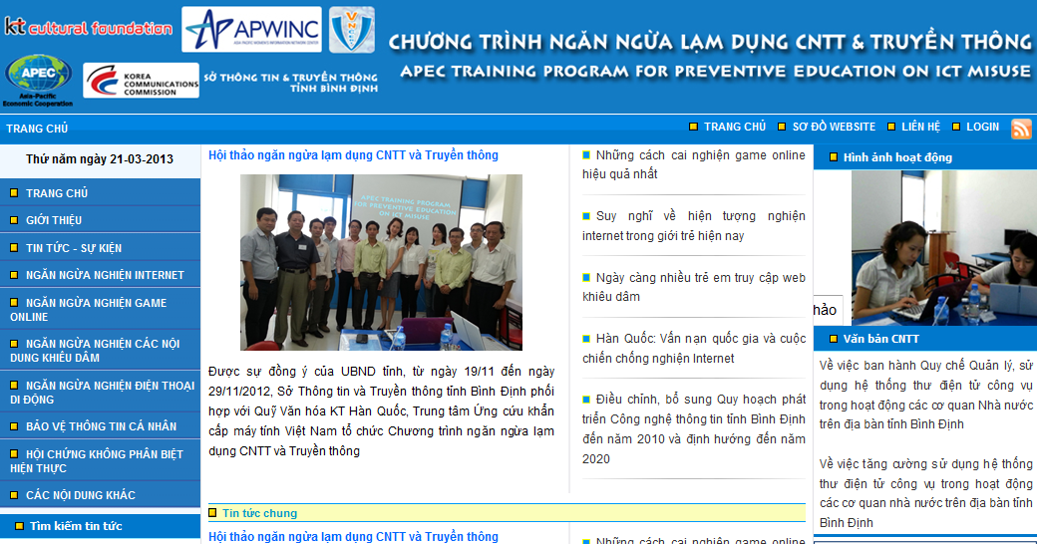
Main page of e-module

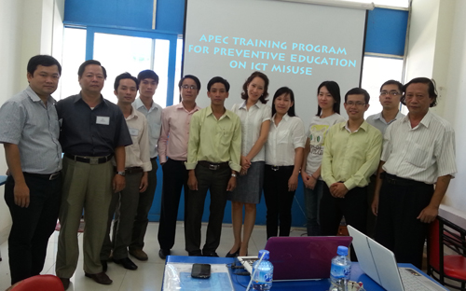

Experts attend in EGW

These experts, the most critical group, directly led all training sessions, and especially were the trainers during TOT. These 10 experts participated in the entire training period from EGW to Debriefing.

b. Training of Trainers – TOT (November 25-27, 2012):
The TOT group was responsible for developing future trainers of this course. Selected to attend TOT were 20 secondary teachers from 11 districts. During the 3-day-TOT, four selected topics were introduced to the teachers. They also discussed and created documents which were used in preparing lessons for students. They became the trainers during EUT and participated in our training from TOT.

c. End Users’ Pilot Training – EUT (November 28, 2012):

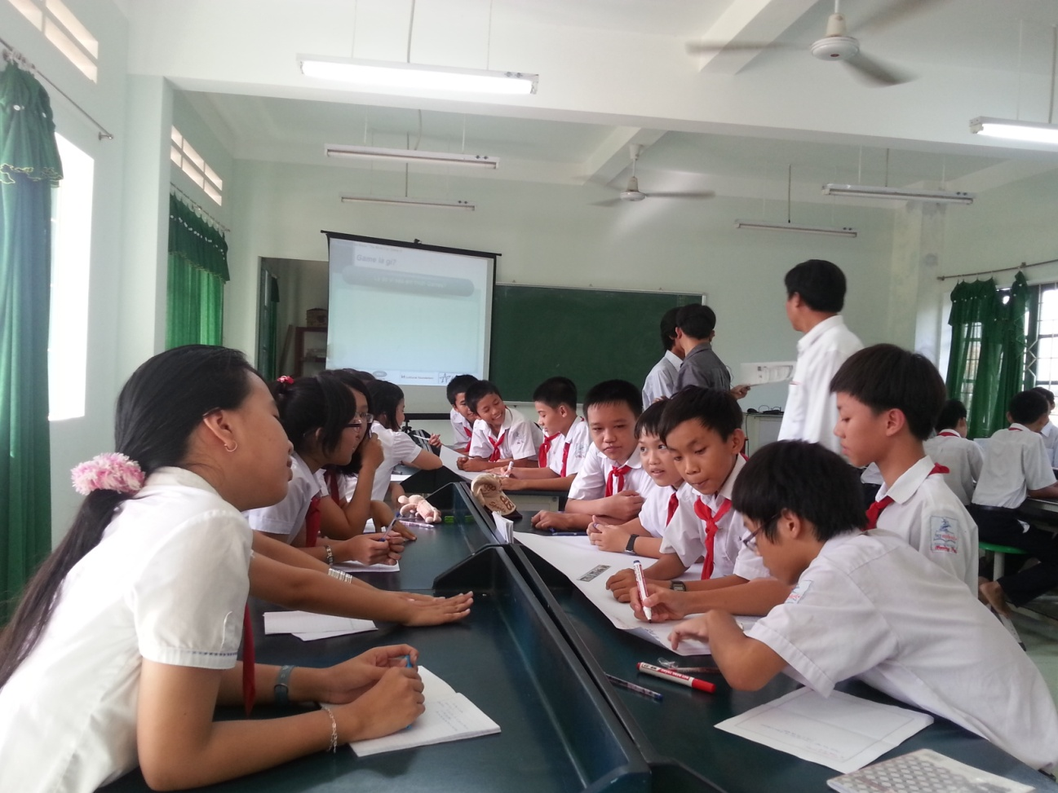

Secondary students in EUT

The EUT group engaged in a simulation teaching class. Our TOT group became the EUT trainers. EUT participants were secondary students at three schools in Quy Nhon city. In two hours at each school, our trainer introduced two topics (“Game Addiction” and “Protecting Personal Information”) to 130 students.

d. Debriefing and Evaluation of Training Program (November 29, 2012):
In this session, all experts and teachers were invited to share feedback about the whole project. Many ideas were discussed and a plan to utilize the created documents at each district was presented.

Benefits and Achievements

Guided by the theme “Protect Yourself from the Internet,” the project contributed to heightened teacher and student awareness of the advantages and disadvantages of the Internet. Moreover, it also provided teachers with necessary knowledge about Internet addiction, game addiction, pornography addiction, mobile phone addiction, reckless clicks and zombie PCs, phishing, protection of personal information, etc. Through the training course, teachers were also provided with useful methods and tools to recognize the symptom of Internet addiction and recommended solutions to reduce the number of Internet-addicted students.

As for students, this project helped them to understand more deeply the disadvantage of Internet addiction and encouraged them to engage in sports as well as healthy activities.
The documents (including e-Module, flash files, PPt files, video clips) provided through the training course were utilized in many secondary schools in order to conduct extracurricular activities. In this sense, it is expected that 21,450 students from 165 secondary schools in Binh Dinh Province will have been given the opportunity to learn the e-module by March 2013.

Evaluation

“APEC Training Program for Preventive Education” implemented in Binhdinh – Vietnam has proven to be a very useful project. Although the project was implemented over a brief period of time, it positively impacted teachers and students. Many local government departments, teachers, parents highly appreciated our project. Not only parents but also local government departments hope that there will be a similar project conducted in the future to help them decrease children’s Internet addiction.

- Wrap-up Workshop in TELWG 47 (2013)

In order to wrap-up the project which has gone through last 4 years-run, as already included at the project details upon the approval, the project hosted the ‘Workshop on APEC Training Program for Preventive Education on ICT Misuse’ in Legian Kaja room, Padma resort, Bali, Indonesia on 23rd April, 2013 TELWG 47 by KTCF and CAID. The workshop provided us with a valuable opportunity where APEC member economies could share the outcomes of the project including 5 trainings in Philippines, Indonesia, Thailand, Malaysia, and Viet Nam. Also, outcomes from ‘International Conference’ in 2009 as well as ‘Poster Display during TELMIN 8’ in 2010 were shared. Especially, to congratulate the success of the project and the wrap-up workshop, stakeholders including Ms. Jordana Siegel (SPSG convenor), Ms. Hanmil Jung (Assistant Director, Ministry of Science, ICT and Future Planning) have presented and made speech.. For the speakers, each project manager of 5 trainings in APEC region was invited and presented about each training pilot run. Ms. Maria Melizza Tan who used to be the Philippino project manager but working in UNESCO Bangkok at the moment gave us a special presentation on the UNESCO’s activities towards the prevention on ICT misuse, and suggested us some ways to collaborate with each other.

- White paper (2013)

The project published ‘White Paper’ which includes all the project activities as well as outcomes. This White Paper has been distributed at the wrap-up workshop as well as meeting in TELWG 47. Also it was uploaded on the project website: www.apecict.net

III. Overall Progress

The brief concept of the project is to achieve practical dissemination of the education contents to prevent ICT misuse through training. Also, discovering successful cases of practical preventive education on ICT misuse highlighted the project’s principles.

Here are four major principal activities suggested in the project proposal and its outcomes.

- It was suggested that a Steering Committee be formed to consist of focal points-of-contact from each national economy, who would be invited to the international symposium for simulation training as well as for sharing ideas about training outside of Korea.
- As the first activity of the project, the international symposium on ‘Safe and Trusted ICT/Internet Use: Actions against Internet Misuse’ was held at Sookmyung Women’s University in Seoul, Korea on 31 August 2009. There, we had 24 invited speakers from APEC TELWG, HRDWG and etc. with more than 150 in attendance. Among the 24 invited speakers, 10 focal points from 7 economies of the APEC region such Australia, China, Indonesia, Philippines, Thailand, Peru and Vietnam were invited to the steering committee meeting held in Seoul, Korea in 1st October 2009. Six of them were from APEC TELWG and the rest were from APEC HRDWG. In addition, three experts from Korea and one expert from ITU joined the committee. Based on the steering committee members’ great effort, the project implemented five training pilot runs, and steering committee members took an important role as the focal points of each representative economy.

- To identify a successful case of preventive education on ICT misuse, the project highlighted the importance of holding pilot runs of training in several economies in the APEC region. Also, to disseminate the project effectively, it was determined that the concept be instilled in local education systems; therefore, the educational contents should be revised accordingly. For effective training, translated educational contents could be provided.
- Over the 4-year long period, the project held five pilot training runs in five different APEC economies: Philippines (2009), Indonesia (2010), Thailand (2011), Malaysia (2011) and Vietnam (2012). For each session, the project developed flexible strategies to implement the training effectively, considering the unique situation of the participating economies. The project utilized translated materials for better understanding of local participants, which was essential to make the training effective and successful. As a result, during the project’s 4-year run; training programs in 5 economies produced 129 trainers and another 281 people trained by the trainers directly. Also through its e-module programs built by trainers in Thailand, Malaysia, and Vietnam, an estimated 85,890 trainees have been trained through the e-modules thus far. Specific data per each economy are follows:

Total beneficiaries from 5 pilot training runs in 5 APEC economies
 | Philippines  (2009) | Indonesia  (2010) | Thailand  (2011) | Malaysia  (2011) | Viet Nam  (2012)
Trainers | 16 | 20 | 50 | 13 | 30
Trainees (direct) | 60 | 48 | - | 43 | 130
Trainees by  e-module | - | - | 3,000 | 61,440 | 21,450
(As of March 2013)

- To contribute to raising awareness on ICT misuse within the APEC region, this project held poster exhibitions, which were organized cooperatively with other related SPSG project such as ‘Cyber Security Awareness Raising’ project.
- ‘Cyber Security Awareness Poster Exhibition’ was held during TELMIN 8 in Okinawa, Japan from 28 to 31 October, 2010. This exhibition was initiated by the project, but it was decided that it be promoted as a part of ‘Cyber Security Awareness Raising Day’ activities in collaboration with Japan, the host economy for TELMIN 8. With strong support from the member economies, we collected 24 posters from 10 represented economies, including Australia, Brunei Darussalam, China, Japan, Korea, Malaysia, Singapore, Chinese Taipei, Thailand, and the U.S.A.

- To wrap up the training results as well as share best practices, a workshop is to be held in APEC TELWG. Further ideas to improve the educational contents are to be discussed during the workshop. A White Paper containing all the experiences and lesson learned during the project is to be presented.
- The White Paper, covering all the activities and achievements of the project, was published for the wrap-up workshop held in Bali, Indonesia on 23 April 2013 during TELWG 47 and distributed. The White Paper is to be distributed also in SPSG meeting in TELWG 47.

IV. Overall Recommendations

The APEC Training Program for Preventive Education on ICT Misuse has contributed to the campaign to raise the alarm over ICT misuse and provide practical preventive education in the APEC region.

Through implementing the activities, specific lessons were learned and those are strongly recommended for similar projects and project providers in the future.

Firstly, the most valuable lessons learned concerned protocols to implement training. Through five diverse training (Philippines, Indonesia, Thailand, Malaysia and Viet Nam), the project always set the same goals for each training run but took different ways to reach the goals. For the preliminary research prior to training, the project team pondered the training methodology with local experts, and fully accepted suggestions without undue hesitation. Each run of training was designed accordingly. When we proposed this project at first, we were only considering ‘customization’ of the educational materials rather than ‘conjugation’, meaning that we only thought about how to change the Korean-produced educational materials for each different trainings run, not how to adapt the educational materials to more precisely fit local contexts. However, as a result of the project outcomes over the 4-year period along with five diverse experiences in implementing training, the project team could realize that the conjugation process in terms of educational contents at the training was the key strategy determining success of the training. For example, during every single training run, Korean educational material were incorporated with local ones so that participants could understand and adopt them easily and efficiently.

Secondly, courses and events using visual contents were successful. Our educational materials included 16 different flash animations in 6 languages. These flash animations provided the momentum that sparked participant interest in the training sessions, thereby highlighting their role as the most effective educational tool for all ages. Based on the awareness that participants showed more interest in visual versus written contents to another activity of the project, we adjusted our approach to include the Cyber Security Awareness-Raising Poster Exhibition (2010). At the Ministerial meeting, whose atmosphere is usually serious and strict, we organized a poster display event for the cyber security awareness raising that turned out to be successful enough to get not only participant attention but also that of ministers as well.

In closing, the project team would like to recommend three key factors behind successful training programs, as follows: 1) Listen to and accept local expert advice, 2) Deliver contents with local education material and 3) Use much visual content in diverse activities.

V. Future Plan

- Follow-up project development

The project will make effort to develop a follow-up project. Any economies to join are all welcomed.

Contact Information

Mr.Chang-Jun Lee
Director, KT Cultural Foundation (KTCF)
Tel: 82-2-3414-2022 Fax: 82-2-3414-2060, lcj@ktcf.or.kr

Ms. Estelle M.S. SHIM
Director, Center for Asia-Pacific ICT Development (CAID)
Tel: 82-10-8804-1459 , estelle.msshim@gmail.com, estelle@caid.re.kr

