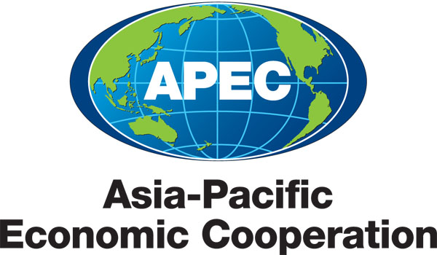
___________________________________________________________________________
2013/ SMEWG37/HLM/DEC

Statement

Submitted by: United States

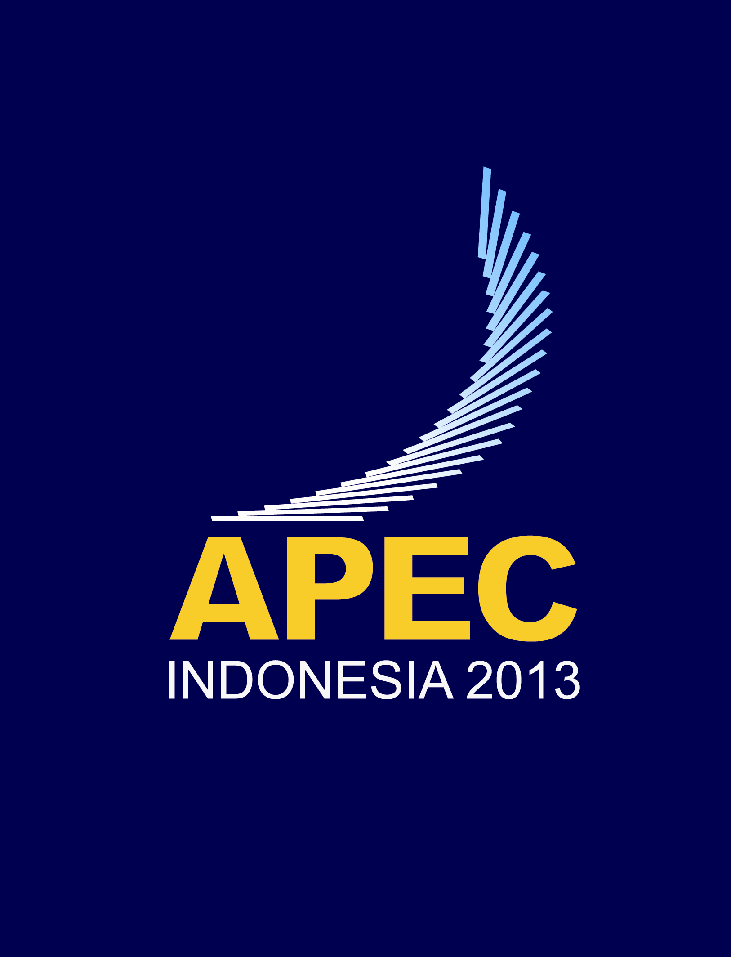 | Healthcare Stakeholder Awareness High-Level Meeting: Fostering Ethical Business Environments in the Medical Device and Biopharmaceutical Sectors  Bali, Indonesia  3 September 2013

APEC Healthcare Stakeholders Awareness High-Level Meeting:
Fostering Ethical Environments in the Medical Device and Biopharmaceutical Sectors
Nusa Dua, Indonesia – 3 September 2013

STATEMENT

With the common goal of building awareness and promoting support for initiatives to foster ethical business practices in the medical device and biopharmaceutical sectors across the 21 Asia Pacific Economic Cooperation (APEC) member economies, we – representatives from healthcare providers and professional organizations, anti-corruption agencies, health ministries, health regulatory agencies, health-related government procurement agencies, biopharmaceutical and medical device associations, and private healthcare companies from across the APEC region – met in Nusa Dua, Indonesia, on 3 September 2013 by joint invitation of the Ministry of Health and Ministry of Cooperatives and SMEs of the Government of Indonesia and by the co-sponsoring economies of the “Business Ethics for APEC SMEs Initiative.”

We recognize that ethical collaboration among industry and healthcare providers and governments promotes broad patient access to life-saving and health-enhancing medical technologies and therapies that are safe, effective and of high quality. Further, we recognize that ethical collaboration is essential to the development of new innovative medical technologies and therapies that meet patient needs. We continued our dialogue about how we can work closely together to strengthen ethical business practices in the healthcare sector.

We affirmed the statements made by APEC Leaders in 2012 that corruption is “...a tremendous barrier to economic growth, the safety of citizens, and to the strengthening of economic and investment cooperation among APEC economies” and that: “we recognize the important role of business and public-private partnerships in promoting the elaborating of codes of conduct in the private sector and measures to fight corruption, especially measure that support the promoting of ethical business practices in interactions between government, business and other stakeholders.”

We also affirmed our support for The Kuala Lumpur Principles for Voluntary Codes of Ethics in the Medical Device Sector as well as The Mexico City Principles for Voluntary Codes of Ethics in the Biopharmaceutical Sector. We acknowledged APEC and its SME Working Group for its leadership in convening expert working groups composed of industry, government and civil society to develop these high standard principles and for providing initial capacity building funds to begin to have them implemented.

We agreed that the creation and endorsement of The Kuala Lumpur Principles and The Mexico City Principles (“the APEC principles”) was an important first step toward promoting sustainable economic growth in the medical sector. We also agreed that as leaders of healthcare provider and professional organizations, senior health regulators and health ministry officials, anti-corruption officials, health products and services procurement agencies, and industry we have a responsibility to take further steps together to promote an ethical health care environment in our economies and in the APEC region. We noted that this work is fundamental to APEC’s core mission of promoting economic cooperation because healthy populations are the foundation of sustainable economic growth and health care products and services account for a growing share of international trade and economic activity as economies develop and as populations age.

We therefore established that each stakeholder has a unique and important role to promote ethical health care environments:

Healthcare Companies should follow high ethical standards, such as the APEC principles, as well as all applicable laws and regulations, as part of their mission to help patients by developing and making life-saving and health-enhancing medical technologies and therapies available.

Healthcare Providers and Professional Organizations have a duty to act in the best interests of patients and recognize the importance of their role in communicating the importance of interactions based on ethical principles, such as the APEC principles, including through complementary activities and ongoing dialogue with all stakeholders.

Health Ministries and Health Regulatory Agencies should recognize the value of industry codes of ethics and encourage all stakeholders to support ethical principles, such as the APEC principles, and national and local industry codes of ethics.

Government and Private Procurement Entities should procure health products and services based on transparent, ethical, clear, and accountable policies, processes and procedures.

Anti-corruption Authorities should objectively apply clear laws, welcome industry self-regulation as complementary to law enforcement, and encourage all companies to adopt and adhere to uniform ethical principles, such as the APEC principles, and national and local industry codes of ethics.

We agreed that sustained capacity building, dialogue, and high level support are crucial to ensuring continued progress.

We therefore called on APEC to institutionalize the “Business Ethics for APEC SMEs Initiative” by creating an ongoing, high-level “APEC Business Ethics Forum” to foster regional cooperation through multiple avenues, including capacity building, best practice sharing, and multi-stakeholder dialogue to address new and emerging business ethics challenges and the role of all stakeholders in strengthening ethical business practices. Such a forum would foster an external business environment and internal company environment that will permit SMEs to operate on a sustainable basis and serve as global suppliers. Ethical collaborations will also promote patient access to life-saving and health-enhancing medical technologies and therapies, as well as support the development of new innovative medical technologies and therapies.

Background
The Asia-Pacific Economic Cooperation (APEC) forum is the region’s premier economic forum, leading numerous initiatives that facilitate economic growth, cooperation, trade and investment in the Asia-Pacific region and among its 21 member economies. Launched in 2010, the “Business Ethics for APEC SMEs” initiative has championed the creation of APEC principles for voluntary codes of business ethics in several sectors of significant importance to SMEs in the region, including the medical device and biopharmaceutical sectors. Heightened ethical interactions in these healthcare sectors are crucial to enhancing patient access to safe and effective medical technologies and therapies, promoting SME innovation, building SME export confidence, and ultimately ensuring that decisions are made in the best interest of patients.

Drafted and finalized by expert working groups in 2011 and endorsed by APEC Leaders, APEC Ministers, and APEC SME Ministers The Kuala Lumpur Principles for Voluntary Codes of Ethics in the Medical Device Sector and The Mexico City Principles for Voluntary Codes of Ethics in the Biopharmaceutical Sector call upon all stakeholders, including governments and healthcare professional organizations, to coordinate with their local industries to advance ethical collaborations consistent with their provisions. In 2012, APEC Leaders called for collaborations to propagate codes of ethics aligned with these APEC principles to promote ethical interactions between government, business, and other stakeholders.

