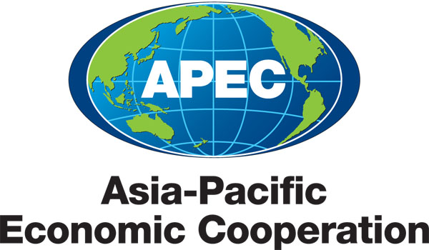
______________________________________________________________________________________
2013/SOM1/019
Agenda Item: 2

CTI Chair’s Report to SOM

Purpose: Consideration

Submitted by: CTI Chair

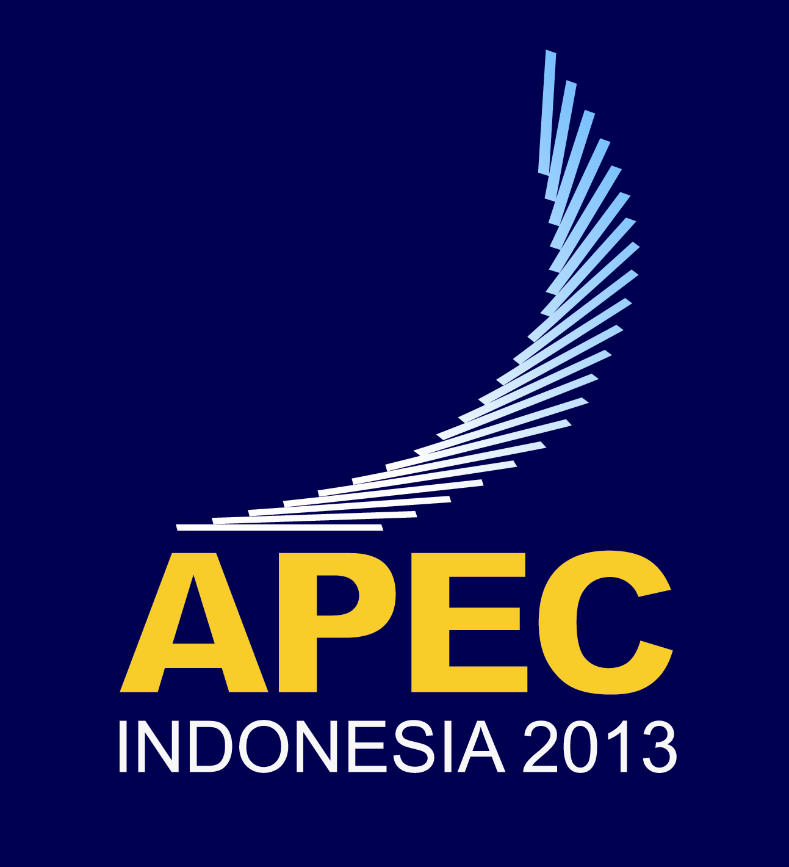 | First Senior Officials’ Meeting  Jakarta, Indonesia  6-7 February 2013

Executive Summary
The Committee on Trade and Investment (CTI) met on 3-4 February 2013 to discuss its Work Program for the year.

CTIs 2013 work program is organized around five priority areas that would contribute to APEC 2013 Priorities under the theme, “Resilient Asia-Pacific, Engine of Global Growth”, namely: (i) support for the multilateral trading system; (ii) attaining the Bogor goals, trade and investment liberalization, regional economic integration; (iii) promoting connectivity; (iv) expanding regulatory cooperation and advancing regulatory coherence; and (v) contributions to APEC growth strategy and cross-cutting mandates. It agreed on work plans in two areas: Next Generation Trade and Investment Issues; and Supply-Chain Connectivity.

Recommendations
CTI recommends that SOM endorse the proposed 2013 CTI work program and the projected list of deliverables from its sub-fora and Industry Dialogues.

CTI recommends that SOM note:

  - the intention of APEC economies to work towards appropriate statements at MRT, AMM and/or AELM on supporting WTO DDA negotiations;

  - the preparations underway for the interim assessment of progress by APEC economies towards the target of a ten percent improvement in supply-chain performance by 2015 and work to advance the systematic approach;

  - the CTI’s intention to convene a TPD at CTI2 to better understand the effects of LCRs on trade and investment and economic growth in the region;

  - the CTI’s intention to look for opportunities for greater collaboration with ABAC and GS1 in relation to relevant aspects of the SCFAP and the systematic approach to improving supply chain performance; and

  - the CTI’s intention to submit at SOM2, a report, including forecast of TILF deliverables for 2013, on progress in all priority areas.

6 February 2013

The Chair
APEC Senior Officials’ Meeting (SOM)
Jakarta, Indonesia

APEC COMMITTEE ON TRADE AND INVESTMENT (CTI): Chair’s Report

Introduction
The Committee on Trade and Investment (CTI) met on 3-4 February 2013 in Jakarta to follow through on the instructions received from Leaders, Ministers and SOM in Vladivostok last September. All CTI sub-fora, except the Automotive Dialogue, had their first meeting of the year prior to this CTI meeting.
CTI Work Program in 2013

2. CTI discussed and aligned its work program around five priority areas that would contribute to APEC 2013 Priorities under the theme, “Resilient Asia-Pacific, Engine of Global Growth”, namely: (i) support for the multilateral trading system; (ii) attaining the Bogor goals, trade and investment liberalization, regional economic integration; (iii) promoting connectivity; (iv) expanding regulatory cooperation and advancing regulatory coherence; and (v) contributions to APEC growth strategy and cross-cutting mandates. It agreed on work plans in two areas: Next Generation Trade and Investment Issues; and Supply-Chain Connectivity.

(a) Support for the Multilateral Trading System

3. CTI discussed a proposal by Indonesia on “Supporting the Multilateral System by Devising APEC Statement to Support the WTO Trade Facilitation Agreement”. While CTI members welcomed Indonesia’s initiative, comments were made concerning the scope of the statement and its comprehensiveness, the role of the APEC Geneva Caucus, the possible need to reflect and support other on-going WTO work, and the timing of the statement including the opportunity afforded by the MRT in April. CTI agreed that it was important for Indonesia to liaise and collaborate closely with the APEC Caucus in Geneva. CTI also agreed that member economies would provide inputs/comments in writing to Indonesia by 28 February for the drafting of appropriate APEC statements on the WTO DDA negotiations ahead of the 9th WTO Ministerial Conference in Bali in December.

4. CTI noted the importance of advancing the negotiations on expanding the product coverage of the WTO Information Technology Agreement (ITA) in response to AELM and AMM instructions from Vladivostok. Many economies emphasized that their representatives in the WTO would work actively towards a successful conclusion. CTI took note that the Market Access Group (MAG) has developed a proposal to organize a Workshop on the Advancement of Information Technology Products and was seeking APEC funding in Session 1.

5. CTI exchanged views on a proposal by Australia on Addressing Harmful Fisheries Subsidies in APEC. While there were several expressions of support, some economies expressed concerns, particularly around the duplication of on-going work stream in WTO and whether the CTI was the appropriate forum to address the actions set out in the proposal. It was agreed that economies would provide comments on the proposal to Australia by 28 February.

(b) Attaining the Bogor Goals

6. CTI discussed a suggestion by the CTI Chair, set out in his letter of 3 January, for a more focused discussion on non-tariff measures/barriers in goods, services and investment in support of Indonesia’s “Attaining the Bogor Goals” priority. This work could be supported by analysis by the PSU and external experts. As part of this discussion, the PSU briefed the CTI on trends as reflected in an updated Bogor Goals Dashboard of Indicators. CTI noted that CTI Chair would circulate intersessionally a paper to take forward his suggestion, including proposed arrangements for such a discussion at CTI2.

7. CTI discussed and agreed to a proposal by Japan, Korea and the United States on Local Content Requirements (LCRs) Annex 1. This will include a proposed trade policy dialogue at CTI2 to better understand the effects of LCRs on trade and investment and economic growth in the region.

8. CTI also discussed a concept note by Indonesia on “Workshops with Aim at attaining the Bogor Goals that ensures Equitable Benefits of Liberalisation” and agreed that economies would provide comments to Indonesia by 8 February with a view of finalizing it for submission for 2013 BMC Session 1 funding.

(c) Exploring an FTAAP

9. CTI welcomed a progress report from Korea on the Regional Economic Integration (REI) capacity building needs initiative, in particular, successful completion of the APEC Workshops on FTA Rules of Origin and FTA Implementation and Outreach and Training Courses on Building and Enhancing Capacities to Participate in FTA-related Environment Negotiations and FTA Negotiation Skills on SPS in 2012. CTI took note of Viet Nam’s interest in holding continued training courses on environment and other activities regarding TBT and government procurement and Chinese Taipei’s interests in continued SPS activities under CBNI. CTI also took note of the updates by the United States on the preparation for the upcoming workshop on trade and labour and China for the upcoming workshop on ecommerce. It also discussed a new concept note by Indonesia for a Capacity Building Workshop on Trade Remedy Provision of RTAs/FTAs Negotiations in the Asia-Pacific region and agreed that economies will provide comments to Indonesia by 8 February with a view of finalizing it for submission for 2013 BMC Session 1 funding.

10. CTI received a presentation by Japan on the outcomes of the Workshop Increasing FTAs Utilisation by SMEs.

(d) Next Generation Trade and Investment Issues

11. CTI adopted a work plan on next generation trade and investment issues to guide its work in 2013 in response to APEC Economic Leaders’ instructions from November 2011 and September 2012 (see Annex 2). CTI, through its FotC on Next Generation Trade and Investment Issues (NGeTI FoTC), received updates on the progress in the previously agreed issues as well as presentations from PSU on its issues paper on SMEs participation in global production chains and the progress of its project on global supply chains on the case study of electrical and electronics industry. The United States asked CTI members to provide input on implementation practices for the 2011 policies on innovation and trade by 28 February.

12. CTI discussed a concept note from Viet Nam for a Workshop on Developing Strategies for Supporting Industries in APEC Member Economies and agreed that economies will provide comments to Viet Nam by 8 February with a view of finalizing it for submission for 2013 BMC Session 1 funding.

(e) Environmental Goods and Services/Green Growth

13. CTI emphasized the importance of economies planning to implement the APEC List of Environmental Goods by the end-2015. CTI also agreed that capacity building may be required to assist with the implementation and encouraged economies to identify those needs. CTI noted China’s intention to submit proposals to improve understanding amongst business stakeholders and relevant government officials about environmental goods and for a public-private policy dialogue on renewable and clean energy products.

14. CTI discussed a proposal from Indonesia on Promoting Green Growth and Practical Road to Inclusive Growth: Promoting Agriculture-Based Goods. In presenting its proposal, Indonesia said it consisted of three elements: a study; a trade policy dialogue; and discussions on the possibility for APEC this year to embark on including new agricultural-based commodities into the APEC EG list agreed last year. Several member economies expressed concerns about the definition and coverage of the agriculture-based commodities/products, how those goods would be selected, the nature of the proposed APEC study, the link between the proposal and the agreed APEC List of Environmental Goods, the need to focus on implementation of the list rather than expansion, and the sensitivities and difficulties of adding products to the list. CTI noted Indonesia’s clarification that the coverage of agriculture-based goods in its proposal was open and not exclusive. CTI agreed that economies should send written comments to Indonesia by 28 February.

15. CTI discussed a proposal from the United States on Trade in Used Electronics, which United States noted should be more accurately titled “Electronics Stewardship”. CTI agreed that economies would submit comments to the United States by 28 February. CTI also agreed that the United States will circulate intersessionally, a draft questionnaire as foreshadowed in its proposal so that comments could incorporated as part of the revised proposal for consideration at CTI2.

(f) Supply-Chain Connectivity Framework and Action Plan

16. CTI adopted a work plan on supply-chain connectivity, developed by the FoTC on Supply-Chain Connectivity, to progress the supply-chain connectivity framework and action plan (see Annex 3). Recognizing the activities in the action plans were either completed, underway or close to completion, CTI noted the need to do more to inject new momentum if economies are to fulfill the commitment of an APEC-wide target of a ten percent improvement in supply-chain performance by 2015, in terms of reduction of time, cost and uncertainty.

17. The PSU briefed the CTI on the progress of the interim assessment of the implementation of the Supply Chain Connectivity Framework Action Plan (SCFAP) through the measurement framework agreed last year. The assessment highlighted that APEC has made significant progress in the overall performance of supply chain transactions. However, member economies will need to increase the rate of progress in some areas going forward.

18. CTI discussed the systematic approach to improving supply chain performance, as agreed by APEC Leaders in Vladivostok. As part of this discussion, CTI received a briefing from the World Bank on their diagnostic analysis of progress in Chokepoint#1. CTI agreed that economies would provide comments on the draft World Bank report by 11 March. The CTI Chair called upon the lead economies for the remaining 7 chokepoints to circulate draft inventories by 11 March for consideration at CTI2.

19. CTI considered the findings from the study by the PSU to assess the economic impact of submarine telecommunications cable disruptions and noted that Australia would develop a proposal for further work within APEC to address collaboration in cable protection, recovery and repair.

20. The CTI was tasked by Senior Officials at ISOM on 7 December 2012 to further examine a proposal by ABAC for a joint task force on global data standards under the SCFAP. As a follow-up, the CTI received a presentation on the proposal by a representative of a not-for-profit industry standards body, GS1, John Keogh. CTI took note of the presentation and the work being undertaken by GS1 with individual economies. The CTI agreed to look for opportunities for greater collaboration with ABAC and GS1 in relation to relevant aspects of the SCFAP and the systematic approach to improving supply chain performance. There was no consensus in the CTI on the establishment of an Implementation Joint Task Force on Global Data Standards at this time.

21. CTI welcomed the presentation from Indonesia on a SOM-level initiative titled, “APEC Infrastructure Development and Investment for Connectivity”. CTI discussed some of the work/activities of CTI and its sub-fora that are relevant to this initiative.

(g) Expanding Regulatory Cooperation and Advancing Regulatory Convergence

22. CTI noted the report by Australia on the outcomes of the 2nd ARCAM Dialogue on self-regulation in advertising held in Hanoi in November 2012. CTI also noted that the SCSC Convenor will consult intersessionally with members to examine and undertake further work, where appropriate, on the recommendations of the report.

23. CTI took note of the requirement to review the ARCAM in 2013 in accordance with the 2010 APEC Regulatory Cooperation Process Mechanism on Trade-related Standards and Technical Regulations. CTI also noted the suggestion by the United States that the ARCAM dialogue be held biennially and that members might consider and endorse the topic for the 2014 ARCAM Dialogue at CTI3. CTI agreed that to further the review, economies will provide inputs and suggestions to the Chair by 11 March. (The Chair will also invite comments from the SCSC). The Chair undertook to summarise the inputs and present options for the ARCAM process for consideration ahead of CTI2.

(g) Contributions to the 2010 APEC Leaders Growth Strategy and cross-cutting mandates

24. CTI received updates from lead economies on projects to address the top barriers to SMEs in trading in the region identified in 2011 by Ministers Responsible for Trade and Ministers Responsible for SMEs, viz:

- For Barrier #6: Problems navigating differing legal, regulatory, and technical requirements, Australia reported that following the successful completion of Phase III of the APEC Services Trade Access Requirements (STAR) database, the database includes information on all APEC economies, along with regulatory information on trade and investment in three new services sectors: education services, distribution services (retail and wholesale) and computer and related services. Australia also mentioned that it was looking at ways to further promote the existence of the database as a resource for businesses across the region including through an enhancement of the website with video demonstrations of Database functionality; and

- On Barrier #9 – Difficulty in Taking Advantage of Preferential Tariff Rates and Other Aspects of Trade Agreements, Peru reported that they have finalized the actions proposed and has collated the brief summaries of FTA benefits provided by some economies. It has also finished working on making this information more user-friendly and easier to use by SMEs. Currently, Peru is discussing with the United States on how to broaden the scope of this proposal. Finally, economies that have not sent their summaries were invited to do it as soon as possible, by 28 February.

The United States shared with the CTI, the progress made by the SMEWG on the implementation of barriers #1 – Lack of Access to Financing and Barriers #3 - Need for Open and Transparent Business Environments.

(i) Other elements of the CTI work program and industry dialogues

25. CTI sub-fora and CTI’s three Industry Dialogues were also asked to develop work plans to assist CTI to implement its priorities, as appropriate. A tabulation summarizing highlights of projected deliverables for 2013 are noted in the Annex 4.

Decision Points for SOM and Requests from SOM

26. CTI recommends that SOM endorse the proposed 2013 CTI work program and the projected list of deliverables from its sub-fora and Industry Dialogues.

27. CTI recommends that SOM note:

  - the intention of APEC economies to work towards appropriate statements at MRT, AMM and/or AELM on supporting WTO DDA negotiations;

  - the preparations underway for the interim assessment of progress by APEC economies towards the target of a ten percent improvement in supply-chain performance by 2015 and work to advance the systematic approach;

  - the CTI’s intention to convene a TPD at CTI2 to better understand the effects of LCRs on trade and investment and economic growth in the region;

  - the CTI’s intention to look for opportunities for greater collaboration with ABAC and GS1 in relation to relevant aspects of the SCFAP and the systematic approach to improving supply chain performance; and

  - the CTI’s intention to submit at SOM2, a report, including forecast of TILF deliverables for 2013, on progress in all priority areas.

John Larkin
Chair, APEC Committee on Trade and Investment

2013/SOM1/CTI/003
2013/SOM1/CTI/019rev1
2013/SOM1/CTI/005
2013/SOM1/CTI/008
2013/SOM1/CTI/007
2013/SOM1/CTI/015rev1
2013/SOM1/CTI/027
2013/SOM1/CTI/010
2013/SOM1/CTI/017

