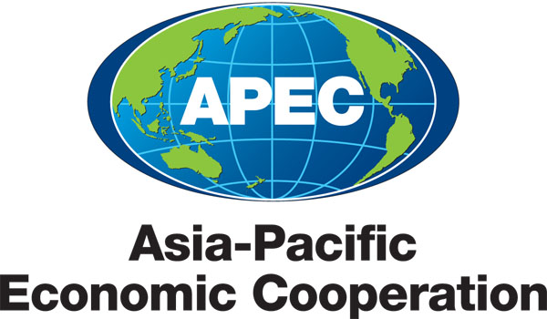
___________________________________________________________________________
2010/SOM3/EC/SEM/001

Agenda

Submitted by: Japan

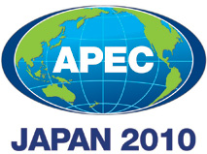 | Seminar on Getting Credit for Small and Medium Enterprises  Sendai, Japan  21 September 2010

Seminar on “Getting Credit for Small and Medium Enterprises”
(1st Phase of Ease of Doing Business Action Plan)
September 21, 2010
Sendai, Japan

VENUE: Room A of the Westin SENDAI (14th floor)

8:30AM –  9:00AM | Registration
9:00AM –  9:05AM | Welcome  - Mr. Yasushi AKAHOSHI  Coordinator of the Strengthening Economic and Legal Infrastructure (SELI) FotC, APEC Economic Committee
9:05AM –  9:15AM | Keynote Speech  - Mr. Makoto SHIOTA  APEC Senior Official of Japan
9:15AM –  10:40AM | Session 1: Ease of Getting Credit
Moderator: Mr. Gary JUDD
Chairman of ASB Bank Ltd.
An ABAC member and co-chair of the Advisory Group on APEC Financial System Capacity-Building

Presentations [15 minutes each]

Doing Business Indicators, in particular the “Getting Credit” Indicator
- Mr. Santiago CROCI
Legal Rights (Secured Transactions) Topic Leader, Doing Business, The World Bank Group
- Mr. Karim O. BELAYACHI
Credit Information Topic Leader, Doing Business, The World Bank Group
- Findings of the Doing Business “Getting Credit” indicator
- Global and Regional best-practices: Where do APEC economies stand today and what are the trends moving forward

Strength of Legal Rights (Collateralization Law, Bankruptcy Law, and Insolvency Law)
- Mr. ZHENG Zhibin
Partner of King & Wood PRC Lawyers
A Member of the Inter-Pacific Bar Association (IPBA)
- How economies can set up a legal system with strong legal rights to incentivize and promote investment and credit availability.
- The impact of bankruptcy and insolvency law in making a decision on where to invest.

Depth of Credit Information
- Dr. Robin VARGHESE
Vice President, Policy and Economic Research Council (PERC)
- How credit information helps enterprises get credit in a cost-effective manner.
- How APEC economies can improve the depth of credit information offered within their economies to make finance more efficient.

Discussion (Question & Answers) [25minutes]
10:40AM –  10:55AM | Coffee Break
10:55AM –  12:00PM | Session 2: SME and Getting Credit
Moderator: Prof. Naoyuki YOSHINO
Keio University, Japan

Presentations [15 minutes each]

Needs from SMEs
- Dr. Tsutomu TATEMIYA
Vice President, Proactive Corporation
A member of the Japan Chamber of Commerce and Industry (JCCI)
- Issues SME face today, in particular in getting credit to conduct and expand their business operations.
- How APEC economies can better address these issues going forward.

Information on Japanese practices for SME assistance.
- Mr. Iichiro UESUGI
Senior Fellow, Research Institute of Economy, Trade & Industry (RIETI), Japan
- How Japan operates its SME assistance programs.
- Impact of Japan’s programs, success stories, and best practices.

Issues particular to SME assistance for women entrepreneurs
- Ms. Aída CERDA
Deputy Director for Labor and Economy, National Women’s Institute, Mexico
- Issues female entrepreneurs face in setting up SME and financing them.
- Opportunities for APEC economies to improve their SME assistance programs to address issues specific to female entrepreneurs.

Discussion (Question & Answers) [20minutes]
12:00PM –  13:30PM | Luncheon  (VENUE: Room SUZUME of the Westin SENDAI (2nd floor)
- Mr. Gary JUDD
Chairman of ASB Bank Ltd.
An ABAC member and co-chair of the Advisory Group on APEC Financial System Capacity-Building
- ABAC's work this year related to Getting Credit for Small and Medium Enterprises

- Prof. Naoyuki YOSHINO
Keio University, Japan
- The Development of SME Credit Information Database to promote SME Lending
13:30PM –  15:00PM | Session 3: Breakout Discussion Session
Group Discussion [45 minutes for each theme]
(VENUE: Room B of the Westin SENDAI (14th floor))

Participants will be divided into four groups, and they will alternate between the following two themes. Speakers are strongly encouraged to participate by leading the discussion under their respective topic.

- Strength of Legal Rights
Moderators:
- Mr. Thomas M. CLARK
Vice President, Government Relations, GE Capital Asia;
Director, U.S. National Center for APEC;
Co-Chair, APEC Task Force and Banking and Finance Committee, American Chamber of Commerce in Japan
- Mr. Santiago Croci
Legal rights (secured transactions) topic leader, Doing Business, The World Bank GroupSpeaker from World Bank

- Depth of Credit Information
Moderators:
- Mr. Karim O. BELAYACHI
Credit information topic leader, Doing Business, The World Bank Group
- Dr. Robin VARGHESE
Vice President, Policy and Economic Research Council (PERC)
15:00PM –  15:15PM | Coffee Break
15:15PM –  15:45PM | Report back from the Breakout Discussion Session  Moderators of the breakout discussion session will briefly report the result of the group discussion to the participants.
15:45PM –  16:00PM | Closing Remarks  - Mr. Yasushi AKAHOSHI  Coordinator of the Strengthening Economic and Legal Infrastructure (SELI) FotC
16:00PM– | Evaluation  Participants will fill in the evaluation form.

