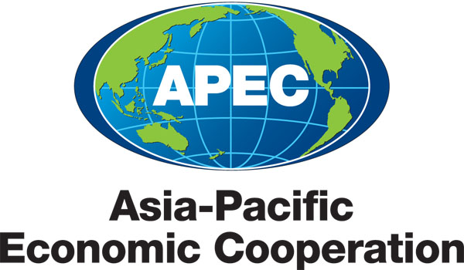
_____________________________________________________________________________________
2010/SOM3/EC/SEM/002

Speakers and Moderators

Submitted by: Japan

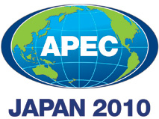 | Seminar on Getting Credit for Small and Medium Enterprises  Sendai, Japan  21 September 2010

Speakers and Moderators

Gary Judd
Gary Judd is the Chairman of ASB Bank Ltd. He has been involved with ASB Bank since 1985 becoming Chairman in 1988. He has been Chairman of ASB Group (Life) Ltd., owner of New Zealand’s largest life assurance company, Sovereign, since 1998. He has been Chairman of Ports of Auckland Ltd. since 2006 and has become Chairman of the Auckland Radio Trust, a charitable trust which re-broadcasts the BBC World Service in New Zealand. He is an ABAC member and co-chair of the Advisory Group on APEC Financial System Capacity-Building.

Santiago Croci
Santiago Croci joined the Doing Business team in the World Bank in March 2008 and works on the Getting Credit - Legal Rights indicator. Prior to joining the team, he worked on an insolvency and creditor rights initiative at the Legal Vice-Presidency of the World Bank Group. He also worked on development issues at the Competitiveness Capacity Building Initiative of the Organization of American States.

Karim Belayachi
Karim Belayachi has been a member of the World Bank/IFC Doing Business project since 2007. He leads the Credit Information team for the Getting Credit indicator. Prior to joining the World Bank, Karim had worked extensively on private sector development issues, from providing technical support to the microfinance sector in the Middle East & North Africa region, to preparing documentaries for a major international news network on the regulatory environment for Small and Medium enterprises.

Zheng Zhibin
Zhibin Zheng joined King & Wood in 2001. He specializes in corporate bankruptcy and reorganization, and securities transactions. He has been appointed by the Chinese courts to carry out administrative duties for the liquidation of more than forty companies and has also been appointed by the China Securities Regulatory Commission to act as legal counsel in the liquidation of various securities companies. He is a member of the Inter-Pacific Bar Association (IPBA).

Robin Varghese
Robin Varghese is Senior Fellow and Research Director of the Political and Economic Research Council. He has worked extensively on issues of information privacy and security, data quality, credit reporting and credit reporting reform in the United States and abroad, media ownership, financial literacy and the use of non-financial data for widening credit access.

Naoyuki Yoshino
Naoyuki Yoshino is a Professor of Economics at Keio University. He obtained his PhD from John Hopkins University in 1979. He was an assistant professor at State University of New York at Buffalo before he joined Keio University in 1991 as a Professor of Economics. He was appointed as a Board Chair of Financial Planning Standard Board (FPSB, USA) in 2007. He serves as a chairperson of Fiscal Council (FILP Section), Ministry of Finance and a chairperson of JGB (Japanese Government Bond) Investors’ meeting at the Ministry of Finance. He was selected as “Who’s Who in the World 2009 and 2010”. He received the World Top 100 Educators’ Award in 2009, Cambridge UK.

Tsutomu Tatemiya
Tsutomu Tatemiya is the Vice president of Proactive Corporation which is a school of International Accounting Education. He is a Small and Medium Enterprise Management Consultant registered by the Minister of Economy, Trade and Industry.

Iichiro Uesugi
Iichiro Uesugi is a Senior Fellow, Research Institute of Economy, Trade and Industry, Japan. He was an Associate Professor, Institute of Economic Research, Hitotsubashi University, Tokyo, Japan from July 2007 to July 2010. He has expertise in Corporate Finance, Small and Medium Enterprises, Japanese Economy, Money Market.

Aída Cerda
Aida Cerda is the Deputy Director for Labor and Economy at the National Women’s Institute of Mexico. She is in charge of designing strategies to implement gender mainstreaming approach in governmental assistance programs, generate diagnostics, research and analysis about the role of women compared to men in labor and economic issues, and increase the knowledge of key actors about this subject. Before that, she worked in the gender department at the Ministry of Economy.

Thomas M. Clark
Thomas M. Clark is the Vice President, Government Relations, GE Capital Asia. He is also the Co-Chair, ACCJ APEC Task Force and Co-Chair, Banking and Finance Committee. He has been in Tokyo with GE for 11 years, first as Chief Legal Counsel for GE Consumer Finance, from 1999 to 2005, and from 2006 in his current position.

Makoto Shiota
Makoto Shiota is the APEC Senior Official of Japan. He is the Deputy Director-General, for International Regional Policy, Trade Policy Bureau, at the Ministry of Economy, Trade and Industry, Japan.

Yasushi Akahoshi
Yasushi Akahoshi is the coordinator of Strengthening Economic and Legal Infrastructure FotC under APEC Economic Committee. He is the Director, Americas Division, at the Ministry of Economy, Trade and Industry, Japan. In this position, he is responsible for bilateral and multilateral issues involving countries in North America and in Latin America.

