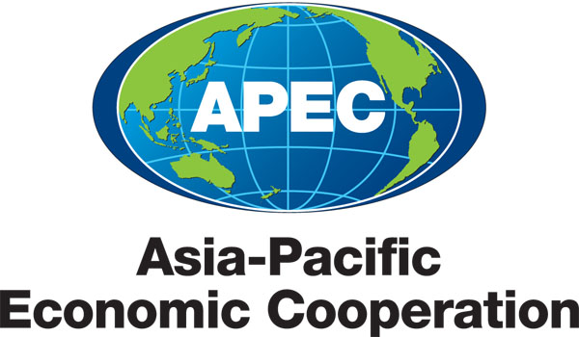
_____________________________________________________________________________________
2010/SOM3/EC/SEM/012
Session 3

Discussion Paper for Breakout Discussion Session

Submitted by: Japan

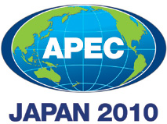 | Seminar on Getting Credit for Small and Medium Enterprises  Sendai, Japan  21 September 2010

Discussion Paper for Breakout Discussion Session

- Strength of Legal Rights
- Are you aware of examples where SME borrowers had difficulty getting credit due to difficulties in enforcing creditor rights in the event of insolvency?
- Do you have any examples of how changes to secured credit and related law in your economy have impacted a particular business?
- From a business perspective, what sort of reforms would you like to see in the region on legal rights in this field?
- If you are considering future reforms in the area of secured transactions, what kind of legal reforms are under consideration in your economy? What areas do you feel you still need assistance in order to improve the legal framework, e.g., modernizing the registry?
- If you have already reformed in the area of secured transactions, what reforms has your economy conducted in the past? What were the lessons-learned from the experience of reform? Was there any impact which resulted from the reform?
- Based on today’s discussions, what could your economy do to improve in the area of secured transactions and the Doing Business Getting Credit indicator?
- Based on today’s discussion, what sort of capacity building efforts should APEC conduct in this field going forward?

- Credit Information
- If you are considering future reforms in the area of credit information systems, what direction do you see your economy moving in this field? (E.g., toward establishing a Private Credit Bureau or Public Credit Registry)
- Based on today’s discussions, what form do you think credit information and provision should take, encompassing both public and private elements?
- How might economies improve their credit information system and EoDB Getting Credit indicator?
- What major obstacles exist to improving your economy’s credit information system? A lack of regulation or existing laws such as privacy laws?
- If you have already reformed in the area of credit information systems, how has your economy changed in this area? What was learned from this experience?
- What capacity building efforts could APEC conduct, for example, to help create or enhance a credit risk database in your economy?

