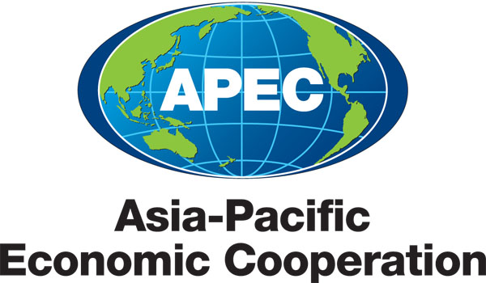
___________________________________________________________________________
2010/EC/WKSP3/000

Document List

Submitted by: APEC Secretariat

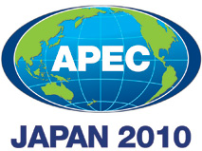 | Workshop on Enforcing Contracts  Seoul, Korea  21-22 June 2010

Document List

Document No. | Title | Submitted By
2010/EC/WKSP3/000 | Document List - Workshop on Enforcing Contracts 2010 | APEC Secretariat
2010/EC/WKSP3/001 | Tentative Program - Workshop on Enforcing Contracts 2010 | Korea
2010/EC/WKSP3/002 | Alternative Dispute Resolution (ADR) in Hong Kong, China | Hong Kong, China
2010/EC/WKSP3/003 | Civil Justice Reform and Its Impact on Civil Litigation in Hong Kong, China | Mayer Brown Practices
2010/EC/WKSP3/004 | Reforms in Japanese Business Rules | Japan
2010/EC/WKSP3/005 | An Overview of Korean Civil Litigation, Alternative Dispute Resolution (ADR) and Execution Proceedings | Korea
2010/EC/WKSP3/006 | The Judicial Process Re-engineering Through e-Filing | Korea
2010/EC/WKSP3/007 | The Use of Information Technology in Enforcing Contracts: The Singapore Journey | Singapore
2010/EC/WKSP3/008 | Ease of Doing Business Action Plan (2010-2015) | Economic Committee

