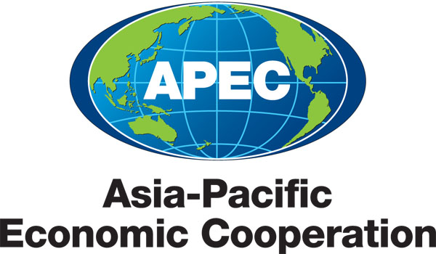
___________________________________________________________________________
2011/SOM2/CTI/SEM/001

Tentative Agenda

Submitted by: China

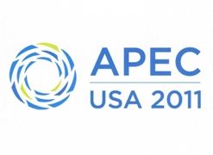 | Seminar on Dissemination of Environmental Technologies  Big Sky, United States  11 May 2011

APEC Seminar on Dissemination of Environmental Technologies
11 May 2011, Big Sky, USA

Tentative Agenda

0830 – 0900 | Registration
0900 – 0920 | Welcome and Opening Remarks
 | - Ms. Monica Contreras Rosales, CTI Chair
Facilitator: | Dr. Zou Ji, Professor, School of Environment and Natural Resources, Remin University, China
0920 – 1040 | Session I
 | Dissemination of Environmental Technologies: General Situation
 | - Current situation of dissemination of environmental technologies
 | - Opportunities and challenges of dissemination of environmental technologies
 | Speakers:
 | - Mr. Lutz Weischer, Research Analyst, World Resources Institute
 | - Dr. Joachim Monkelbaan, Programme Officer, International Center for Trade and Sustainable Development
 | Discussion
1040 – 1100 | Coffee Break
1100 – 1230 | Session II
 | Dissemination of Environmental Technologies: What Matters
 | - Factors and ways facilitating dissemination of environmental technologies
 | - Demand and supply of environmental technologies in APEC region
 | - Implication of dissemination of environmental technologies on trade and investment liberalization
 | Speakers:
 | - Dr. Nares Damrongchai, Director, National Science Technology and Innovation Policy Office, Thailand
 | - Dr. Joachim Monkelbaan, International Center for Trade and Sustainable Development
 | Discussion
1230 – 1345 | Lunch Time
1345 – 1530 | Session III
 | Dissemination of Environmental Technologies: Experience and Best Practice
 | Speakers:
 | - Mr. John Smirnow, Senior Advisor, Solar Energy Industries Association, US
 | - Ms. Mary Newell-Miller, Vice President for Licensing, Honeywell
 | - Mr. Jake Colvin, Vice President, National Foreign Trade Council, US
 | - Ms. Wei Wei, General Manager, International Division, Sound Global
 | Discussion
1530– 1545 | Coffee/Tea Break
1545– 1730 | Session IV
 | Way Forward
 | Speakers:
 | - Mr. Fernando Fischmann, CEO, Crystal Lagoons
 | - Dr. Hu Tao, Independent Expert
 | Discussion
1730 – 1745 | Conclusion

