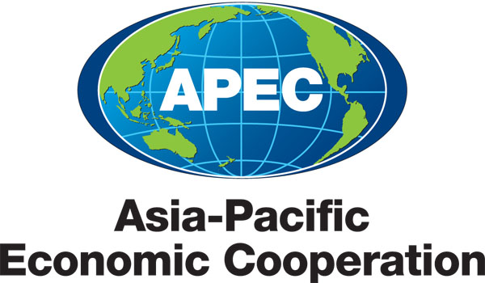
___________________________________________________________________________
2011/SOM2/CTI/TPD/000

Document List

Submitted by: APEC Secretariat

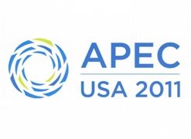 | Trade Policy Dialogue on Environmental Goods Non-Tariff Measures  Big Sky, United States  12 May 2011

Document List

Document No. | Title | Submitted By
2011/SOM2/CTI/TPD/000 | Document List - Trade Policy Dialogue on Environmental Goods Non-Tariff Measures 2011 | APEC Secretariat
2011/SOM2/CTI/TPD/001 | Draft Agenda - Trade Policy Dialogue on Environmental Goods Non-Tariff Measures 2011 | CTI Chair
2011/SOM2/CTI/TPD/001a | Speakers Biographies | United States
2011/SOM2/CTI/TPD/002 | Non-Tariff Measures in RE Policies | World Bank
2011/SOM2/CTI/TPD/003 | APEC Region Non-Tariff Measures Affecting Trade and Investment in the Solar Industry | Solar Energy Industries Association (SEIA)
2011/SOM2/CTI/TPD/004 | Ideas for APEC Action Moving Forward | Sustainable Business Australia (SBA)
2011/SOM2/CTI/TPD/005 | Understanding of Environmental Goods Non-Tariff Measures Impacts | APEC Secretariat (On Behalf of Independent Expert)
2011/SOM2/CTI/TPD/006 | Trade and Investment in Clean Power Generation – Significance and Risks | Rhodium Group (RHG)
2011/SOM2/CTI/TPD/007 | Global Business Letter on Environmental Technologies | National Foreign Trade Council (NFTC)
2011/SOM2/CTI/TPD/008 | Non-Tariff Measures in Clean Energy: Next Steps for APEC | World Resources Institute

