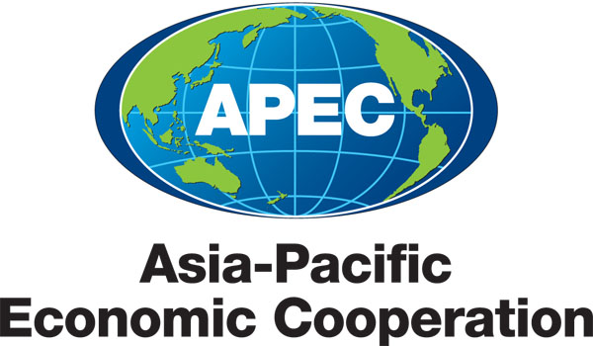
___________________________________________________________________________
2011/SOM2/CTI/TPD/001

Draft Agenda

Submitted by: CTI Chair

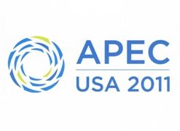 | Trade Policy Dialogue on Environmental Goods Non-Tariff Measures  Big Sky, United States  12 May 2011

Environmental Goods Non-tariff Measures (NTMs) Trade Policy Dialogue
Committee on Trade and Investment (CTI)
Missouri Ballroom
Yellowstone Conference Center
Big Sky, Montana
May 12, 2011

Objective: In 2010, APEC Leaders agreed that APEC would “prioritize[ing] work related to addressing non-tariff measures on environmental goods, technology, and services.” The objective of this trade policy dialogue is to have an informal discussion among APEC officials, private sector representatives, and other experts aimed developing a better understanding of NTMs impacting environmental goods (EGs) trade, and discussing options for how APEC might address EGs NTMs in its work. We propose to invite speakers from a variety of EGs producers and exporters doing business in the APEC region, government officials, and representatives from international organizations and think tanks with expertise in this area.

Program:

9:00 a.m. WELCOME

Monica Contreras Rosales, CTI Chair

9:05 a.m. INTRODUCTION

Dr. Joanne Loundes, Department of Foreign Affairs and Trade, Australia, EGS FOTC Lead

9:10 a.m. CONTEXT setting: Why do EGS Trade and Investment Matter to Green Growth?

Shashank Mohen, Rhodium Group

9:30 a.m. SESSION 1: Gaining a better understanding of NTMs impacting EGs trade and investment in the region

Speakers:
John Smirnow, Solar Energy Industries Association (SEIA)
Mahesh Sugathan, The World Bank
Professor Hu Tao, Independent Expert, China

10:30 a.m. Question and Answer

Coffee Break: (15 minutes)

11:00 a.m. SESSION 2: Discussion of specific ideas for APEC action moving forward

Jake Colvin, National Foreign Trade Council (NFTC)
Lutz Weischer, World Resources Institute (WRI)
Andrew Peterson, Sustainable Business Australia (SBA)

11:50 a.m. OPEN DIALOGUE AND DISCUSSION

Facilitator: Jennifer Prescott, Office of the United States Trade Representative

Participants: CTI Delegates and Invited Guests

12:50 p.m. SUMMARY AND CONCLUSION

Dr. Joanne Loundes, Department of Foreign Affairs and Trade, Australia, EGS FOTC Lead

