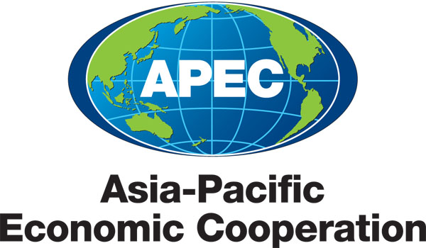
___________________________________________________________________________
2011/SOM2/CTI/TPD/001a

Speakers Biographies

Submitted by: United States

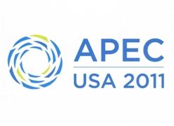 | Trade Policy Dialogue on Environmental Goods Non-Tariff Measures  Big Sky, United States  12 May 2011

Speakers Biographies

Jake Colvin is Vice President for Global Trade Issues at the National Foreign Trade Council, a business association which promotes an open, rules-based global economy on behalf of its member companies, which include Boeing, Caterpillar, General Electric, Microsoft and Wal-Mart Stores. Jake leads the Council's efforts to promote trade policy solutions to climate change and directs a project dedicated to modernizing global trade rules through the World Trade Organization. From 2005-2009, he directed USA*Engage, a business coalition established under the Council to promote U.S. economic, diplomatic and citizen engagement in the world. Jake has written for a variety of outlets including Business Week, Comedy Central, Forbes, Politico and Reuters, has provided analysis on economic and foreign policy issues for CNN, NPR, Time Magazine and U.S. News and World Report, and has testified before Congress on behalf of the Council. Originally from Long Island, New York, he is a graduate of the Johns Hopkins School for Advanced International Studies and the University of Richmond.

Dr. HU Tao is an independent consultant for environmental economic policies. He used to be the Senior Environmental Economist of Policy Research Center of Ministry of Environmental Protection (MEP), China. He served as the Program Coordinator of UN-China Climate Change Partnership Framework Program (CCPF) during 2009-2010 and served as a member of Lead Expert Group China Council for International Cooperation on Environment and Development (CCICED) during 2001-2007. He is also the Chief Expert of WTO and Environment Expert Group of Ministry of Environmental Protection (MEP), China. He is/was visiting professor of Renmin University of China (RUC), Beijing Normal University (BNU), and University of Oregon, and is an affiliate Faculty Member of College of Business, Oregon State University, US.. He also provides environmental policy consulting services for World Bank, Asian Development Bank, Global Environmental Facility and other international and foreign aid organizations.

Shashank Mohan is Senior Analyst of the Energy & Climate Practice at the Rhodium Group (RHG), a specialized advisory partnership based in New York conducting original economic research on complex global themes. His work focuses on energy markets, environmental regulation, international energy security and global climate change. Prior to joining RHG, Mr. Mohan worked on a World Bank project to design an electricity expansion model for Kenya, and as a software engineer at Microsoft. Mr. Mohan’s publications include Assessing the American Power Act: The Economic, Employment, Energy Security, and Environmental Impact of Senator Kerry and Senator Lieberman’s Discussion Draft (2010), A Green Global Recovery? Assessing U.S. Economic Stimulus and Prospects for International Coordination (2009), and National electricity planning in settings with low pre-existing grid coverage: Development of a spatial model and case study of Kenya (2008).

Andrew Petersen is the Chief Executive Officer of Sustainable Business Australia (SBA). SBA is the peak organization in Australia for the environment and sustainability industry. The association is active in developing growth strategies to improve access to domestic and export markets, and stimulating public awareness of environmental issues. Before Andrew was appointed the CEO of SBA in March 2011, he was the Legal and Sydney Advisory Partner of the Sustainability and Climate Change Services Team of Pricewaterhouse Coopers (PwC) Australia based in Sydney. Andrew has established an enviable reputation as an advisor to ASX 200 leading companies on matters relating to environmental risk, including climate change, director liability and natural resource management. Andrew is well known to Australian business for his commentary in the media on the business implications of climate change. Andrew was a business representative for SBA on the Australian Government delegation to the UNFCCC (2005), and has been a delegate to the UNFCCC CO/.MOPs for over 10 years. Andrew holds a Bachelor of Arts and Bachelor of Law degrees.

John P. Smirnow is Senior Advisor for Trade & Competitiveness to the Solar Energy Industries Association (“SEIA”). Established in 1974, SEIA is the national trade association of the U.S. solar energy industry. As the voice of the industry, SEIA works to make solar a mainstream and significant energy source by expanding markets, removing market barriers, strengthening the industry, and educating the public on the benefits of solar energy. John is a former trade attorney at a leading international law firm. He also served as Legal Advisor to the Chairman of the U.S. International Trade Commission and Law Clerk to the Honorable R. Kenton Musgrave of the U.S. Court of International Trade. John is a Member of the Trade & Environment Policy Advisory Committee and Renewable Energy & Energy Efficiency Advisory Committee, where he provides trade policy advice to the U.S. Trade Representative, U.S. Environmental Protection Agency Administrator, and U.S. Secretary of Commerce. John received his Master of Law degree in International and Comparative Law from the Georgetown University Law Center and his Juris Doctor degree from the Thomas M. Cooley Law School, where he served as Articles Editor and Board Member for the Thomas M. Cooley Law Review. John is also a graduate of the University of Michigan, with a Bachelor of Arts degree in History.

Mahesh SUGATHAN is Programme Coordinator for Economics and Trade Policy Analysis with the International Centre for Trade and Sustainable Development in Geneva, Switzerland and is presently engaged as a consultant to the World Bank. At ICTSD, he has worked on a broad range of issues, including trade, development, environment and agriculture. His areas of expertise are trade in environmental goods and services and trade, climate change and sustainable energy. He has published as well as spoken extensively on these issues at numerous international conferences. At the World Bank he is presently engaged in a pilot project on “Assessing Investment Climates for Doing Climate Business” with a focus on South Asia. Mr. Sugathan has a Masters degree in International Law and Economics from the World Trade Institute in Bern, Switzerland. Mr. Sugathan completed undergraduate and graduate studies in Economics and International Relations at the University of Kerala and the Jawaharlal Nehru University in New Delhi, India. He also holds an M.Phil from Jawaharlal Nehru University.
Lutz Weischer is a Research Analyst with the World Resources Institute’s Climate and Energy Program. He works on the Two Degrees of Innovation platform to help build a global innovation system for clean energy where great ideas can rapidly emerge and spread globally. This robust and dynamic global innovation system will be needed to catalyze significant improvements in the cost and performance of low carbon energy technology. His work focuses on innovation beyond the lab - improvements throughout the life cycle of the technology and across the entire energy system. He analyzes global trade and investment flows in renewable energy technologies and the policy drivers that encourage their deployment and continuous improvement. As part of this work, he also follows the international negotiations on climate technology issues at the United Nations, the Clean Energy Ministerial and other fora. As an expert on trade and climate change, Lutz also coordinates WRI’s work on these issues. Before joining WRI, he has worked for the World Trade Organization’s Trade and Environment Division and the United Nations Environment Program. He holds a degree in Political Science from the Free University of Berlin and a Master in International Affairs with a specialization in Sustainable Development from the Paris Institute of Political Studies (SciencesPo).

