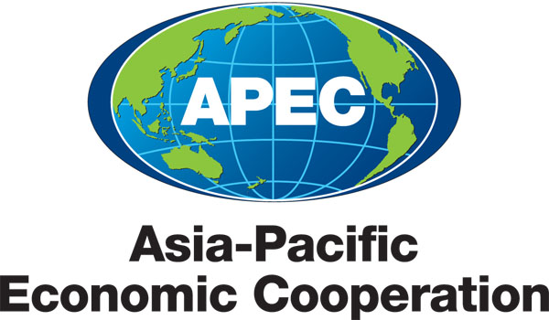
___________________________________________________________________________
2013/SOM3/CTI/WKSP1/000

Document List

Submitted by: APEC Secretariat

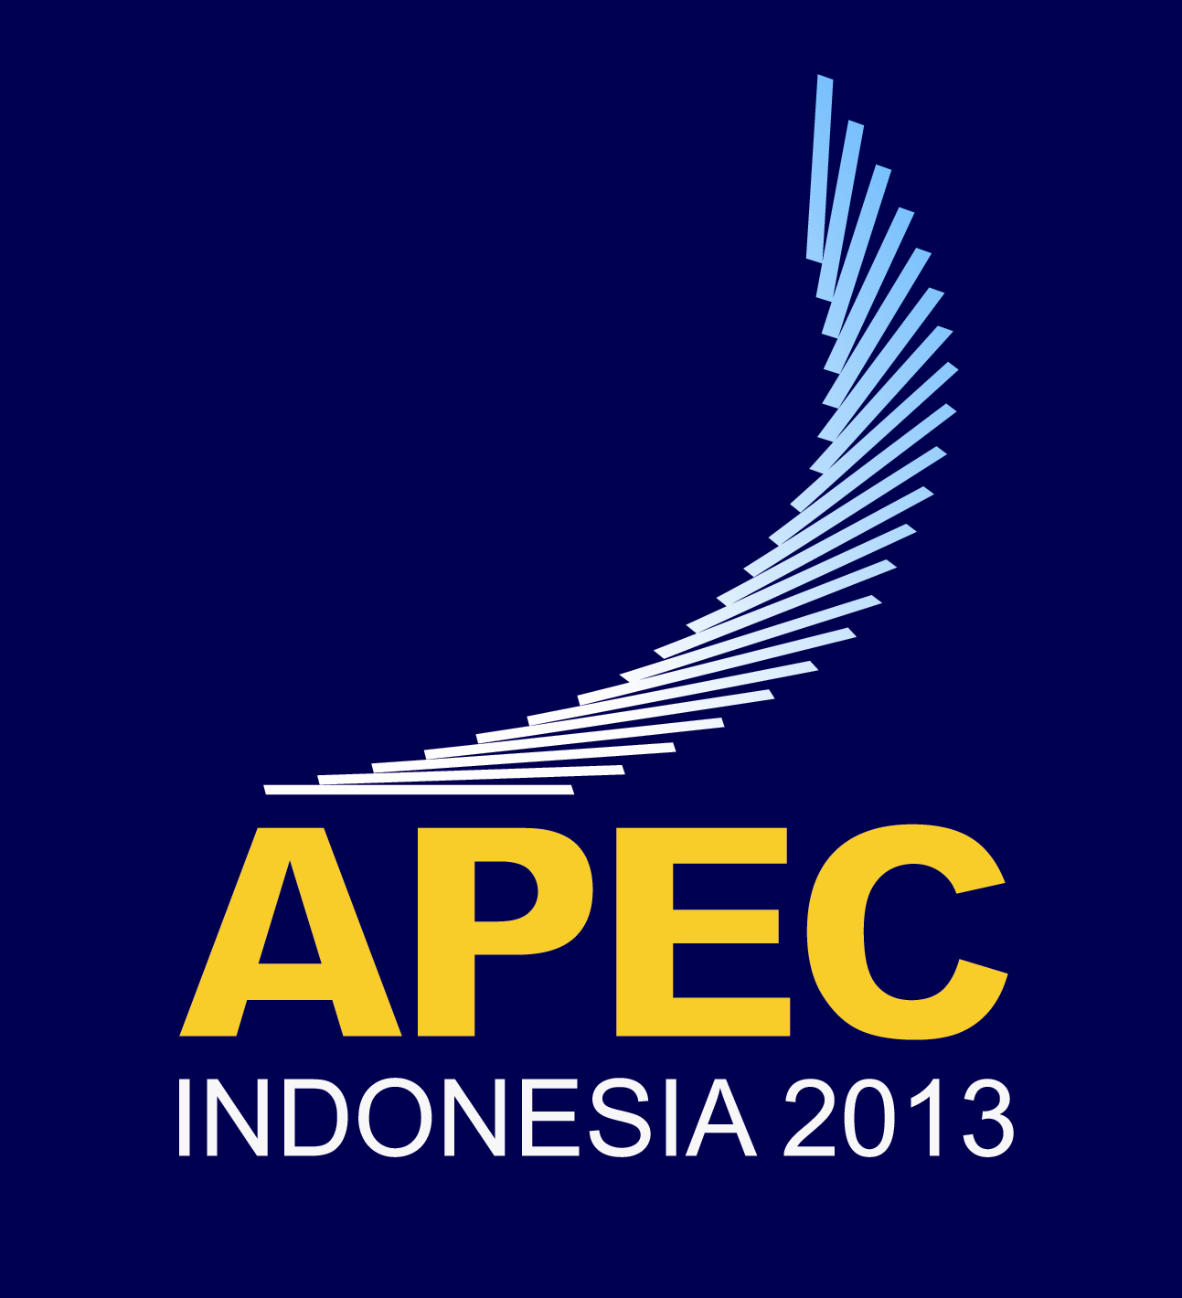 | Workshop on Building and Enhancing FTA Negotiation Skills on e-Commerce  Medan, Indonesia  27-28 June 2013

Document List

Document No. | Title | Submitted By
2013/SOM3/CTI/WKSP1/000 | Document List – Workshop on Building and Enhancing FTA Negotiation Skills on e-Commerce 2013 | APEC Secretariat
2013/SOM3/CTI/WKSP1/001 | Agenda - Workshop on Building and Enhancing FTA Negotiation Skills on e-Commerce 2013 | China
2013/SOM3/CTI/WKSP1/002 | Peru’s Experience on FTA Development and Negotiation Skills on e-Commerce | Peru
2013/SOM3/CTI/WKSP1/003 | Private Sectors Perspective | Rakuten Asia Pte Ltd
2013/SOM3/CTI/WKSP1/004 | FTA Negotiations: The Philippine Perspective | Philippines
2013/SOM3/CTI/WKSP1/005 | Experience Sharing and Opportunities with FTA | China
2013/SOM3/CTI/WKSP1/006 | Policies and Its Experience on e-Commerce in Previous FTAs | Korea
2013/SOM3/CTI/WKSP1/007 | Australian Experiences of Privacy and Consumer Protection Regulation | Australia
2013/SOM3/CTI/WKSP1/008 | Recommendations for Future Cooperation | Thailand
2013/SOM3/CTI/WKSP1/009 | Cross-Border e-Commerce Development and Its Implication for FTA Negotiation: APEC and China | China
2013/SOM3/CTI/WSKP1/010 | e-Commerce for Trade Facilitation | China
2013/SOM3/CTI/WSKP1/011 | Electronic Commerce in Free Trade Agreement | Japan
2013/SOM3/CTI/WKSP1/012 | Trustmark in Thailand | Thailand
2013/SOM3/CTI/WKSP1/013 | FTAs and e-Commerce a Private Sector Perspective | Intel Technology Asia Pte. Ltd
2013/SOM3/CTI/WKSP1/014 | e-Commerce Negotiations | United States
2013/SOM3/CTI/WKSP1/015 | e-Commerce Development in Asia and the Pacific | ESCAP

