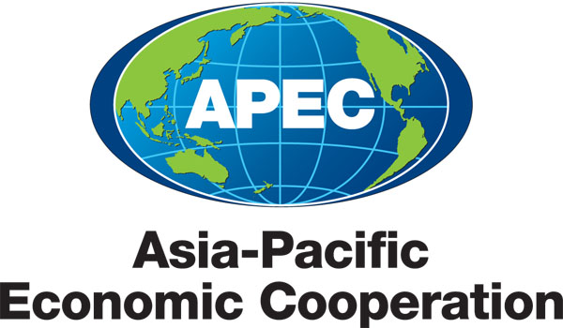
___________________________________________________________________________
2013/SOM3/CTI/WKSP1/001

Agenda

Submitted by: China

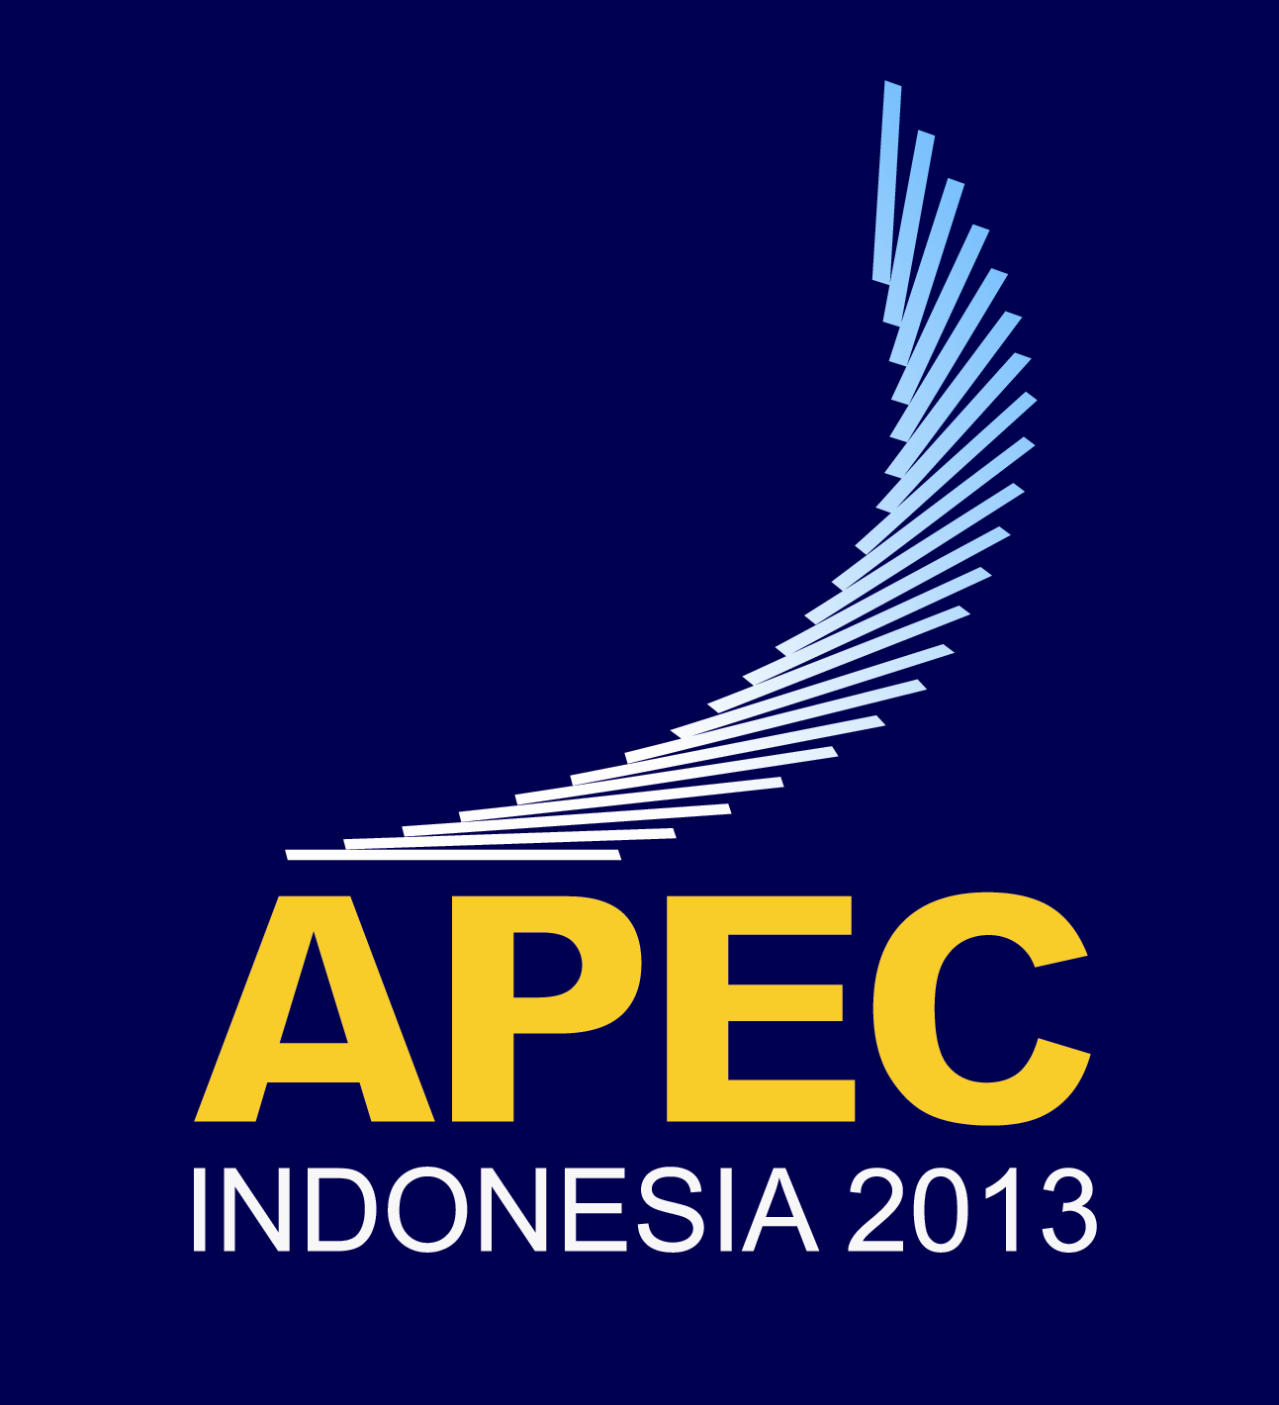 | Workshop on Building and Enhancing FTA Negotiation Skills on e-Commerce  Medan, Indonesia  27-28 June 2013

APEC Workshop on Building and Enhancing FTA Negotiation Skills on E-Commerce
June 27-28th, 2013
Medan, Indonesia
Agenda
Day 1
08:45- 09:00 Registration
09:00- 09:15 Opening Remarks
Mr. Nianlu Zhang, Secretary-General, APEC e-Commerce Business Alliance
Session 1: Status setting
Moderator:
Ms. Hilary McGeachy, Executive Officer, Department of Foreign Affairs and Trade of Australia
09:15-10:15 Part 1: E-Commerce development in APEC region
This session will discuss the current development of E-commerce in APEC region, focusing on emerging opportunities and challenges on cross-border e-commerce. New trends of E-commerce development within this region and their effect on international trade will also be discussed at this session.
Speakers:
- Mr. SangWon Lim, Economic Affairs Officer, UNESCAP
- Mr. Jian Wang, Professor, University of International Business and Economic, China
Discussion (Q&A)
10:15- 10:30 Coffee Break
10:30- 12:30 Part2: FTA Negotiation on E-Commerce
This part will discuss the current status and emerging issues of e-commerce in trade forums and agreements, including at the multilateral, regional, and bilateral level with a focus on more recent agreements.
Speakers:
- Ms. Hilary McGeachy, Executive Officer, Department of Foreign Affairs and Trade of Australia
Discussion (Q&A)

12:30- 14:00 Lunch
Session 2: Negotiation Skills and business opportunities sharing
Moderator:
Mr. SangWon Lim, Economic Affairs Officer, UNESCAP
14:00- 15:30 Part 1: From negotiators’ Perspective
In this part, FTA negotiators from several economies will discuss the skills of E-commerce negotiation and how to share them among APEC members.
Speakers:
- Mr. Mitsuhiro Yolota , Director for FTA/EPA Negotiations, Trade Policy Bureau, Ministry of Economy, Trade and Industry(METI), Japan
- Ms. Paulette Hernandez, Senior International Trade Specialist, U.S. Department of Commerce
- Ms. LEE Jungwon, Deputy Director of Ministry of Trade, Industry & Energy(MOTIE), Korea
Discussion (Q&A)
15:30- 15:45 Coffee Break
15:45- 17:30 Part2: From private sectors perspective
In this part, representatives from private sectors will share the successful experience as well as business opportunities of how E-commerce industries can utilize FTA agreements.
Speakers:
- Mr. John Matheson, Director of Legal Policy-Asia-Pacific, Intel Technology Asia
- Mr. Feng Xiao, CEO of OneTouch.cn, China
- Mr. Tadahisa Terao, Chief Strategy Officer, Rakuten Asia Pte. Ltd, Japan
- Mr. KF Cheng, Senior Director, International Business Development, DHGate.com, China
Discussion (Q&A)

Day 2
09:00-09:15 Remarks by John Larkin, CTI Chair, Department of Foreign Affairs and Trade, Australia
Session 3: Way forward
Moderator:
Mr. Jian WANG, Professor, University of International Business and Economics,China
09:15- 10:00 Recommendations for future cooperation
In this session, speakers and active participants of APEC economies will share their experience of FTA negotiations on E-Commerce. They are also encouraged to share their expectation and views, and raise some useful recommendations on future cooperation in this area.
Speakers:
- Mr. SangWon Lim, Economic Affairs Officer, UNENSCAP
- Mr. Pawoot Pongvitayapanu, President of Thai E-Commerce Association, Thailand
10:00-10:15 Coffee Break
10:15- 11:45 Recommendations for future cooperation (continue)
International between speakers and active participants including presentation of active participants
11:45- 12:00 Closing

