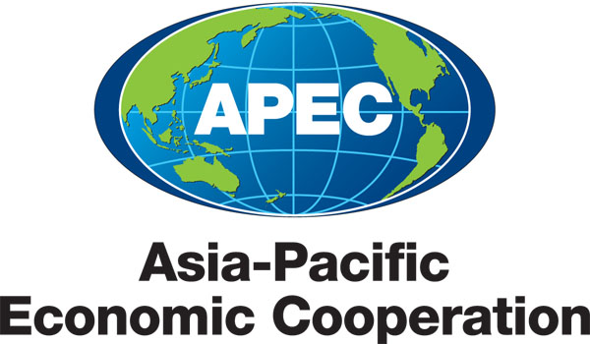
___________________________________________________________________________
2013/SOM3/CTI/WKSP2/000

Document List

Submitted by: APEC Secretariat

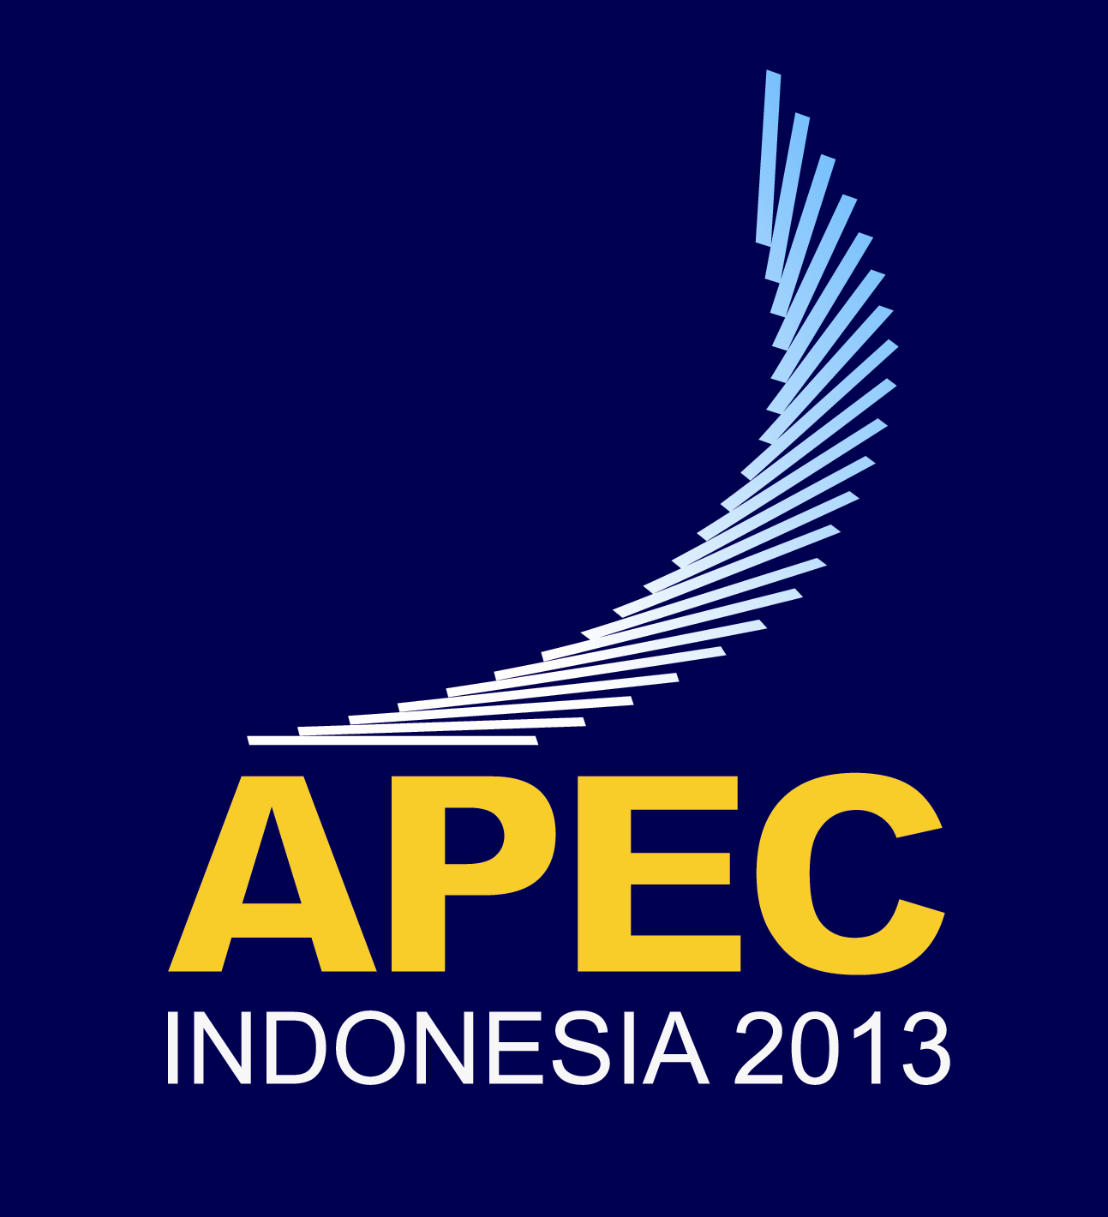 | Capacity Building for Negotiating Labor Provisions in FTAs Workshop  Medan, Indonesia  28-29 June 2013

Document List

Document No. | Title | Session | Submitted By
2013/SOM3/CTI/WKSP2/000 | Document List - Capacity Building for Negotiating Labor Provisions in FTAs Workshop 2013 | - | APEC Secretariat
2013/SOM3/CTI/WKSP2/001 | Draft Agenda - Capacity Building for Negotiating Labor Provisions in FTAs Workshop 2013 | - | United States
2013/SOM3/CTI/WKSP2/002 | Speaker Biographies | - | United States
2013/SOM3/CTI/WKSP2/003 | Introduction – The Trade and Labor Nexus | 1 | Canada
2013/SOM3/CTI/WKSP2/004 | The Trade and Labour Nexus - Evolution of Australia’s Thinking | 1 | Australia
2013/SOM3/CTI/WKSP2/005 | Incorporating Labour Provisions in Trade Agreements | 2 | Chile
2013/SOM3/CTI/WKSP2/006 | Evolution of Canada’s Labour Provisions | 2 | Canada
2013/SOM3/CTI/WKSP2/007 | International Labour Rights | 3 | Chile
2013/SOM3/CTI/WKSP2/008 | Core International Labor Standards | 3 | Rutgers Business School
2013/SOM3/CTI/WKSP2/009 | Labor Provisions in Free Trade Agreements | 4 | United States
2013/SOM3/CTI/WKSP2/010 | Labour Provisions – Canada’s Approach | 4 | Canada
2013/SOM3/CTI/WKSP2/011 | Improving Labour Capacity Through Cooperation and Technical Assistance - The Canadian Experience | 5 | Canada
2013/SOM3/CTI/WKSP2/012 | Challenges to Negotiating Labour Provisions in Trade Agreements | 6 | Australia
2013/SOM3/CTI/WKSP2/013 | Labor Provisions in Free Trade Agreements - Core Obligations | 4 | Peru

