
___________________________________________________________________________
2013/SOM3/CTI/WKSP2/002

Speaker Biographies

Submitted by: United States

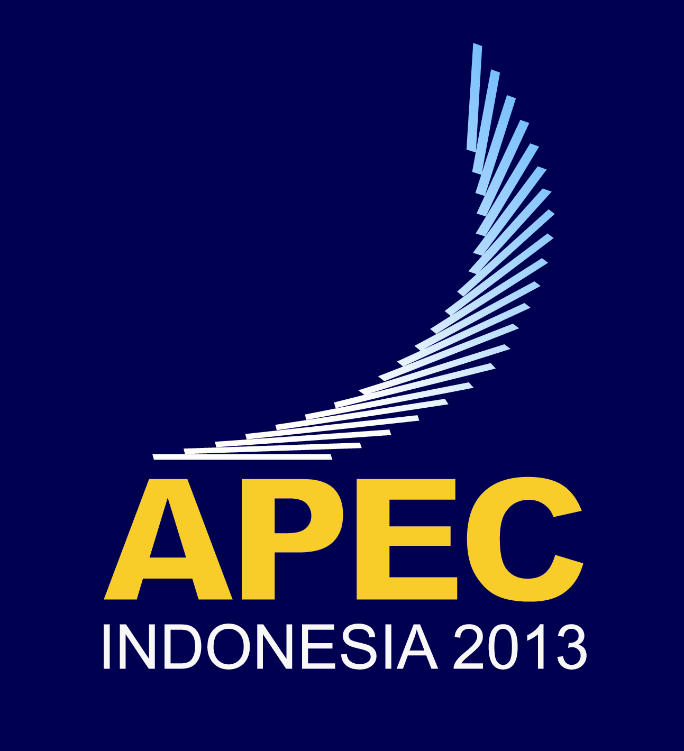 | Capacity Building for Negotiating Labor Provisions in FTAs Workshop  Medan, Indonesia  28-29 June 2013

Speaker Bios

Mr. Pierre Bouchard
Director, Bilateral and Regional Labour Affairs
Canadian Department of Human Resources and Skills Development

Pierre Bouchard is the Director of the Bilateral and Regional Labour Affairs division of the Labour Branch of the Canadian Department of Human Resources and Skills Development. As such, he is responsible for the negotiation and implementation of the labour provisions of Canada’s Free Trade Agreements as well as for the supervision of Canadian technical assistance in the labour area. Mr. Bouchard worked previously at the Canadian Department of Foreign Affairs and International Trade. He holds an M.A. in International Affairs from Carleton University in Ottawa and has done Ph.D. studies in international relations at the London School of Economics and at the Université du Québec à Montréal. Mr. Bouchard lectured at several universities in the field of international relations, particularly on topics related to international political economy, strategic studies and human rights.

Mr. Alvaro Diaz Bedregal
Economic Studies and Consulting Manager
Peru Society of Foreign Trade (COMEXPERU)

Mr. Alvaro Diaz Bedregal is the Economic Studies and Consulting Manager at the Peru Society of Foreign Trade. In this role, he conducts the activities of economists focused on issues related to taxation, labor and health regulations, logistics, and environmental regulatory analysis. Mr. Diaz Bedregal previously spent ten years working with the Peru Ministry of Trade and Tourism on issues related to the negotiation and implementation of Free Trade Agreements (FTAs). From 2010-2012, he served as the Chief Coordinator for the U.S.-Peru FTA and the Canada-Peru FTA.
In 2002, Mr. Diaz Bedregal was awarded distinction by the Minister of Trade and Tourism for his work on the eligibility process for the Andean Trade Promotion and Drug Eradication Act (ATPDEA). He holds a law degree from the Pontificia Universidad Catolica Law School in Lima, Peru.

Mr. Kevin Kolben
Associate Professor
Rutgers Business School

Professor Kevin Kolben is a recognized expert on transnational labor regulation, and labor governance in supply chains. He is on the faculty at Rutgers Business School, and he has also been a visiting senior fellow at the University of Melbourne Law School, and a visiting professor at the Buchmann Faculty of Law at Tel Aviv University.
Mr. Kolben frequently presents his work around the world, and has given presentations at Harvard Law School, Stanford Law School, Notre Dame Law School, the University of Melbourne, and Tel Aviv University, among others. In addition to his academic work, he frequently consults with governmental and non-governmental organizations such as the International Labor Organization (ILO), and the United States Agency for International Development (USAID). Professor Kolben is currently serving on the Federal Advisory Committee for Labor Provisions of Trade Agreements in the United States Department of Labor. Professor Kolben holds a B.A. from Oberlin College, a J.D. from the University of Michigan, as well as an M.A. in South Asian Studies also from the University of Michigan.

Mr. Pablo Lazo Grandi
Attorney Advisor
General Directorate of International Economic Affairs
Chile Ministry of Foreign Affairs

Mr. Pablo Lazo Grandi serves as an Attorney Advisor with the Chile Ministry of Foreign Affairs General Directorate of International Economic Affairs. In this position, he has worked as a principal negotiator on labor matters related to international trade agreements. Prior to joining the Ministry of Foreign Affairs, Mr. Lazo spent eleven years working with the Chilean Ministry of Labor and Social Security. He also has worked as a consultant for the International Labor Organization (ILO) and other international organizations, as well as authoring various papers on international labor matters.

Nguyen Manh Cuong
Adviser to Minister for International Labor Affairs and
Director of the Center of Industrial Relations Development (CIRD)
Vietnam Ministry of Labor, Invalids, and Social Affairs

Mr. Nguyen Manh Cuong is the International Labor Affairs Adviser to the Vietnam Minister of Labor, Invalids, and Social Affairs, and also the Director of the Center of Industrial Relations Development (CIRD). He has held these positions since 2009. Prior to 2009, he spent two years as the Director General for Industrial Relations, five years as the Deputy Director for International Cooperation, and two years as the Chief of the Ministry’s International Organizations section. Cuong holds a Master’s degree in Public Policy from Princeton University’s Woodrow Wilson School of Public Policy. He also holds Bachelor’s degrees from Hanoi National Economics University in Labor Economics and form Leningrad Mining University in Mine Survey.

Mr. Peter Rennert
Lead Negotiator for Labour, Regulatory Coherence, Development, and C

Mr. Peter Rennert has worked on trade policy issues in the Australian Department of Foreign Affairs and Trade since 1993 . Peter was first involved in trade and labour issues in the lead-up to the first WTO Ministerial Conference in Singapore in 1996. In his current role, he is Australia’s lead negotiator for labour, regulatory coherence, development, and competitiveness and business facilitation in the Trans Pacific Partnership (TPP) Agreement. Peter has been Chair of the TPP Labour Working Group since March 2012.

Mr. Timothy Wedding
Deputy Assistant United States Trade Representative for Labor Affairs
Office of the U.S. Trade Representative

Dr. Wedding is the Deputy Assistant United States Trade Representative (USTR) for Labor Affairs. He has responsibility for negotiating and implementing labor-related provisions of U.S. trade agreements and programs. His work has included negotiations under the Trans-Pacific Partnership trade agreement; implementation of labor provisions of U.S. trade agreements with trade partners such as Bahrain, Dominican Republic, Jordan, Korea, Mexico, Morocco and Oman; and worker rights reviews under U.S. trade preference programs. Prior to USTR, Dr. Wedding held the position of Director for Policy and Planning in the U.S. Department of Labor’s Bureau for International Labor Affairs (ILAB), as well as other positions within ILAB. He also worked at the U.S. Government Accountability Office, a Congressional agency, on international trade and economic issues. Dr. Wedding has his Ph.D. in economics (international trade) from Tulane University.

