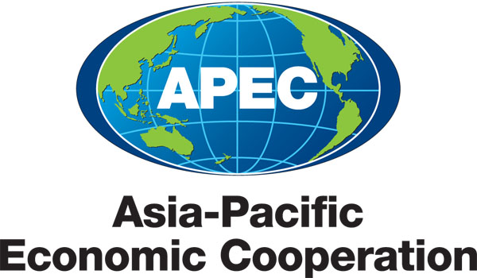
_____________________________________________________________________________________
2013/SOM3/PPFS/004
Agenda Item: 5, 8, 9

Encouragement of Involvement of Farm Leaders in the Discussion at the Partnership on Food Security
Purpose: Information
Submitted by: Japan

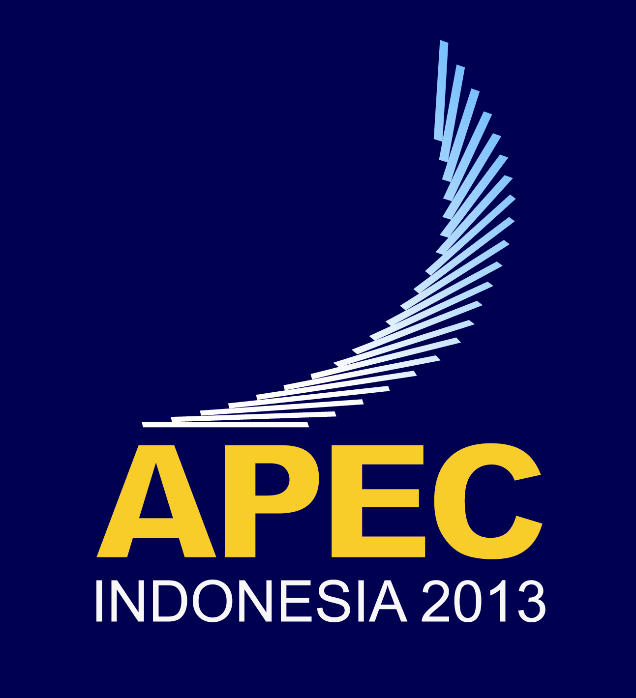 | Second Policy Partnership on Food Security Meeting  Medan, Indonesia  22-25 June 2013

WG2: Sustainable Development of Agricultural and Fishery Sector
Priority3: Strengthening farmer cooperation

Encouragement of Involvement of Farm Leaders in the Discussion at the APEC-PPFS
An Input by Hirofumi Kobayashi, Japan
Medan, North Sumatera, 22-24 June 2013

- Rational
- At the heart of the solution to food security are the farmers, men and women. They are the ones who grow the crops, raise the livestock, manage the land and safeguard natural resources. There can be no food security without farmer security.
- In this context, the Farmers’ Day is an important step to deepen the discussion about food security in this region. The leadership taken by the Indonesian government on this regard is appreciated.
- Farm leaders at the national, regional and/or international level, as well as leaders of consumers, should be involved more in the discussion at the APEC-PPFS.

- Farm Organizations at the Regional and International Level

- Asian Farmers’ Group for Cooperation (AFGC)

- Establishment
- October 1999 in Tokyo, Japan

- Objective
- To exchange information and experiences and to activate cooperation among the member organizations

- Members
India National Cooperative Union of India
Indonesia* Advocacy Center for Indonesian Farmers
Japan* JA Zenchu
Korea* National Agricultural Cooperative Federation
Malaysia* NAFAS
Philippines* Federation of Free Farmers
Sri Lanka Independent Farmers’ Network of Sri Lanka
Thailand* Cooperative League of Thailand
Vietnam* Vietnam Cooperative Alliance
* APEC member economies

- Activities
- Information sharing on common interests of farmers, such as WTO, FTA, climate change, food and energy security and the 2014 International Year of Family Farming
- Implementation of micro-project for empowerment of farmers funded by JA Zenchu

- Policy Orientation
- Identity of Asian agriculture, food consumption and societies
- Sustainable development of paddy field farming is a key to achieve food security for countries in Asian monsoon region
- Access to food must be respected amid energy, food and financial crises
- Principles that must be taken consideration in agricultural trade negotiations
  - Liberalization of agricultural trade should not be regarded as an end in itself
  - Raising the levels of domestic food self-sufficiency must be the primary goal
  - Necessary balance of rights and obligations between food-exporting and –importing countries must be secured
  - The achievement of food security to mainstream sustainable agriculture is imperative
  - A transparent and rules-based safeguard mechanism and anti-dumping measures should be established
  - A system of food reserves on a worldwide and regional basis should be established
  - Small farmers and their organizations should be regularly consulted and actively involved during trade negotiations
  - Sufficient consideration on the unique characteristics of fisheries and forestry products should be given
- Improvement of quality of life and development of sustainable agriculture should be pursued ion the FTAs among countries in Asian monsoon region
- Business linkages among AFGC member organizations are necessary in a globalized and liberalized environment

- World Farmers Organization (WFO)

- Establishment
- September, 2011 in Stellenbosch, South Africa

- Objectives
- Contribute to global food security by facilitating cooperation between the associated organizations to improve farmers’ position in the food chain around the world
- Facilitate the organization of agricultural producers and enable them to improve their position in the food supply chain
- Encourage and enable farmers’ involvement in sustainable rural development, the environment such as climate change, the renewal of generations and gender equality

- Members (as of April, 2013)
[APEC Region]
Australia National Farmers’ Federation
Canada Canadian Federation of Agriculture
Japan JA Zenchu
National Chamber of Agriculture
National Council of Farm Policy Organizations
Korea National Agricultural Cooperative Federation
New Zealand Federated Farmers of Newzealand
USA National Farmers Union
[Asia] Cambodia, Jordan
[Africa] Burundi, Congo, Côte d’Ivoire, Ghana, Kenya, Malawi
Mozambique, Rwanda, South Africa, Uganda, Zambia
[Europe] Albania, Austria, Belgium, Croatia, Cyprus, Denmark, Finland,
France, Germany, Ireland, Italy, Netherland, Norway, Poland,
Spain, Sweden, Switzerland, UK
[Latin America] Argentina, Brazil, Paraguay

- Activities
- Represent its members in governmental, non-governmental and inter-governmental venues, with a view to encouraging the world’s farming community to establish and develop contacts, relations and partnership
- Promote and advocate on behalf of farmers, encouraging the creation of adequate agricultural policies
- Encourage partnerships among its members, as well as with international organizations, executing agreements, protocols and conventions with other bodies and third parties in general
- Conduct and promote research, in-depth analysis and studies, as well as support and organize conferences, meetings and seminars on topics and arguments of interest to the Organization

- Policy
- The following policy documents have been adopted;
  - “WFO recommendation for eliminating rural poverty and achieving food security” adopted in April, 2012 in Rome, Italy
http://www.wfo-oma.org/food-security/policy-documents.html
  - “WFO policy paper on climate change and agriculture” adopted in April, 2012 in Rome, Italy
http://www.wfo-oma.org/climate-change/policy-documents.html
  - “A fair and balanced functioning food chain” adopted in April, 2012 in Rome, Italy
http://www.wfo-oma.org/value-chain/policy-documents.html
  - “WFO policy on international trade” adopted in April, 2013 in Niigata, Japan
http://www.wfo-oma.org/trade/policy-documents.html

